Exploring Business & Marketing Review

Standard 1 – Basic Business
Scarcity – The state of being scarce or in short supply.
Demand - the amount of a good/service that consumers are willing to buy.
Supply - The amount of a good/service available for purchase.
Opportunity Cost - the item, experience, or idea that is lost when you choose something else.
Human Resources – The people that do, create, or work.
Natural Resources - materials or substances such as minerals, forests, water, and fertile land that occur in nature and can be used for economic gain.
Capital Resources - Goods made and used to produce other goods and services.
Copyright - the exclusive legal right, given to an originator or an assignee to print, publish, perform, film, or record literary, artistic, or musical material, and to authorize others to do the same. Copyright is formed automatically as soon as the work is in tangible form.
Trademarks - a symbol, word, or words legally registered or established by use as representing a company or product.
Patents - a government authority or license conferring a right or title for a set period, especially the sole right to exclude others from making, using, or selling an invention.
Sole Proprietorship - A business owned and operated by one person.
Partnership - A business owned by two or more people who operate the business as co-owners.
Corporation - a company or group of people authorized to act as a single entity (legally a person) and recognized as such in law.
Non-Profit Organization - A type of business where success is measured by the achievement of goals, not the accumulation of cash.
Cost/Benefits - The benefits of a given situation or business-related action are summed and then the costs associated with taking that action are subtracted.

Standard 2 – Human Resources

Resumes – A brief written account of personal, education, and professional qualifications and experience, as that prepared by an applicant for a job.
Cover Letter – A letter sent with, and explaining the contents of a resume, asking for an interview.
Human Resources – The personnel of a business or organization
Human Resources Department – a critical component of employee well-being in any business. Responsibilities include payroll, benefits, hiring, firing, and keeping up to date with state and federal tax laws.

Standard 3 – Entrepreneurship

Entrepreneur – A person that starts, organizes, and assumes the responsibility for a business
What traits does and entrepreneur need?

Standard 4 – Marketing

Marketing Mix - The marketing mix refers to the set of actions, or tactics, that a company uses to promote its brand or product in the market. The 4Ps make up a typical marketing mix - Price, Product, Promotion and Place.
Product – The item offered for sale. Can be a good, service, or idea. Every product is made at a cost and sold at a price.
Place – Also known as distribution, Place refers to the channel, or route through which goods move from the source to the final user.
Price – The value that is put to a product or service and is the result of a complex set of calculations, research and understanding and risk taking ability.
Promotion - Refers to raising customer awareness of a product or brand, generating sales, and creating brand loyalty.
Goods, Services, Ideas – Goods are tangible, Services are performed by other people, Ideas is changing the way other think or feel about something.
Digital Marketing - The marketing of products or services using digital channels to reach consumers. The key objective is to promote brands through various forms of digital media. Digital marketing extends beyond internet marketing to include channels that do not require the use of the internet.
Logos – A graphic mark or emblem used to identify a company, organization, product, or brand.
Slogans – A shorty catch phrase that identifies a product or company.
Personal Selling - is where businesses use people (the "sales force") to sell the product after meeting face-to-face with the customer. The sellers promote the product through their attitude, appearance and specialist product knowledge. They aim to inform and encourage the customer to buy, or at least trial the product.
Public Relations - is a strategic communication process that builds mutually beneficial relationships between organizations and their publics." Public relationscan also be defined as the practice of managing communication between an organization and its publics.
Sales Promotion - Sales promotions are the set of marketing activities undertaken to boost sales of the product or service. Coupons, discounts, etc .
Advertising - the activity or profession of producing advertisements for commercial products or services.
Emotional – Making purchases based on emotion such as love, anger, sadness, etc.
Rational – Making purchases based on logic and research
Patronage - Making purchases based on loyalty to a brand or product.
Target Market – A particular group of consumers at which a product or service is aimed
Market Segmentation – Dividing a broad market into subsets that have common needs, interests, priorities, etc., and then designing and implementing strategies to target them. Segmentation is Geographic (where they live), Demographic (observable traits such as race, religion, etc) , Psychographic (how they think), or Behavioral (what they do).
Demographics – Segmentation according to race, religion, gender, family size, ethnicity, income, education, etc.

Standard 5 – Accounting
Income Statement - a financial statement that measures a company's financial performance over a specific accounting period. Compares revenue and expenses.
Budget – Planned BEFORE spending, a budget is a layout of how the company plans to spend and receive income. Compares Income and Expenses.
Balance Sheet - A statement of the assets, liabilities, and capital of a business or other organization at a particular point in time, detailing the balance of income and expenditure over the preceding period.
Assets = Liabilities + Equity
Revenue – Income a company generates
Expenses - The money spent or cost incurred in an entity's efforts to generate revenue
Assets – An economic resource such as cash, property, buildings, etc.
Liabilities – Obligations of a company or organization. Amounts owed to lenders and suppliers.
Liquidity – How quickly an asset can be transformed into cash. Cash is the most liquid asset.

Standard 6 – Stock Market
Stocks – A share of ownership in a company
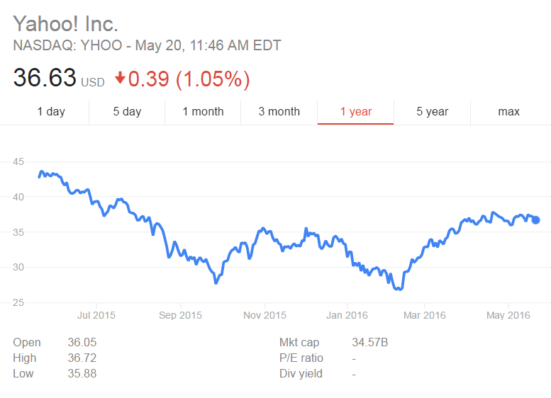
Bonds – An investor loans money to an entity for a defined period of time at a variable or fixed interest rate.
Mutual Funds – A pool of funds collected from many investors for the purpose of investing in securities such as stocks, bonds, etc.
Dividends – A sum of money paid regularly by a company to its shareholders out of its profits.
Debt – something, typically money, that is owed or due.
Interest – Money paid regularly at a particular rate for the use of money lent.
Risk/Reward Rule – Compares expected returns of an investment to the amount of risk undertaken to capture these returns.
Time Value of Money – The idea that money available at the present time is worth more than the same amount in the future due to it’s potential earning capacity.
Compound Interest - Interest calculated on the initial principal and also on the accumulated interest of previous periods of a deposit or loan.
Bull/Bear – A market that is rising is a Bull market, a market that is dropping is a bear market.

Standard 7 – Leadership

Mission Statement – A formal summary of the aims and values of a company, organization, or individual.
Goals – What a company expects to accomplish over a specific period of time.
Vision – Provides strategic direction and describes what the owner or founder wants the company to achieve in the future.
Teamwork – The process of working collaboratively with a group of people in order to achieve a goal.
CTSO’s – DECA and FBLA are clubs/organizations at the high school level that can further your experience in this area.
DECA – An international organization of high school and college students and teachers of marketing, management and entrepreneurship in business, finance, hospitality, and marketing.
FBLA (Future Business Leaders of America) – Non-profit organization for middle, high school, and college students as well as professional members, who primarily help students transition to the business world. It is the largest student-run organization in America and one of the largest business level organizations in the world. Students participate in academic competitions, network with professionals at conferences, and do community service projects. Members get exclusive access to scholarships from a select group of academic institutions.

