College & Career Awareness Orientation Activity
Career Clusters

Learning Objective: Introduce the 13 Career Clusters and what types of occupations go inside each cluster. Students will understand the concept that choosing a career is easier when they choose a cluster of careers in their interest area.

Needs:

- 13 Bags, labeled with each pathway. (Bottomed bags with a handle will last the longest)
- 50+ Ping Pong balls (make sure not to get plastic—they are harder to write on!)
- Ultra Fine Point Permanent Markers with at least 13 colors

Preparation:

- Using markers and the job list, write the name of each job by color on the ping pong balls. You will only have to do this once—then you’ll have it for all future classes!
  - You can also print them on labels and attach them to each ball, but it can be difficult to keep it stuck
  - If you get the cheap plastic kind, the writing will come off with sweaty hands. Learned this the hard way…
  - You can use something other than ping pong balls—even just cards they pick up can work as well.
- Put all of them in a large bin or tub where the kids can see them as they are coming in.
- Label each bag and lay them aside. I like to put magnets across my white board where I can hang each of them up as I introduce them.

Lesson:

- Ask a random student to come up and choose a ball from the bin at random. Ask them if they’d like that job, or if they’d like to switch for another. Let them keep choosing until they get a job they liked. Keep track of HOW MANY TIMES they switched balls. Do the same process with a few more students, depending on how much time you have. Keep track—you could even average the number of times students switched out their ping pong balls.
  - If you want to be overly dramatic and don’t mind the cleanup, it might be fun to just full on dump the entire bin on the floor and tell the students to find the one they like best. It will be crazy—the kids will scramble around and try to find a “good one.” But it WILL get the point across!
  - Have each student choose 1-3 balls (depending on how many you made) and hold on to them until needed for the next portion.
- Discuss how long it took to find the right occupation. Some looked longer than others, but few got one they really wanted on their first try. If there are only 10 jobs you’d like in the pile, but there are 100 options, what are the chances you’ll randomly pick the right one on your first try?
- And yet, some people seem to follow the exact course when looking for an occupation. They scramble around, picking one thing then another, with no real direction or purpose. It can take them years and lots of failures in the wrong areas to find what they really like to do.
- But if a student chooses a Career Cluster, they may have a much more efficient path to finding their future career.
- One by one, pull out the bags you have labeled and introduce the 13 career clusters. Make sure to explain what types of occupations go under each heading. After you introduce each cluster, ask the students to look at the balls they have and see if any of them belong in that bag. Discuss each ball that is placed in that cluster bag and WHY it belongs in that career cluster. Do this for all 13 until all the bags are neatly arranged with their corresponding bags.
  - If you have color coded the jobs with markers, it will be easier to see which jobs go in which bag. You can make it harder by just labeling all balls with the same color.
- Now ask the students if any of them are pretty sure which career cluster they are the most interested in. Choose a student to draw out one of the balls in that bag and ask them if they would consider that job. There is a lot less guess work when you know which cluster you are aiming for!
- 7th Grade is the first year that you are allowed to choose your courses. Your options are limited, but as each year of school goes by, your options increase more and more. By the time you reach high school, you will have over 200 electives to choose from instead of the 6 or 8 that you have now. Make each elective count. Choose electives that will lead you to a career either by teaching you skills you will need or by enriching your character to prepare you to handle what you’d like to do in the future.
- Each cluster has many pathways that branch from it. For instance, you may choose the Information Technology, and then choose the Web Design pathway. Many of these pathways can be followed all through high school. If you complete enough classes in that pathway, you get a special cord at graduation, and you will receive certifications in that field that will make you ready to work.
- The sooner you find a pathway, the quicker your route to a career you love and can support yourself and a future family with. Otherwise, you may spend the rest of your life scrambling around going from job to job, hoping you happen to pick the right one!

Links:
- https://www.amazon.com/Projects-Coloring-Birthdays-Super-Outlet/dp/B0118AJP6A/ref=sr_1_17?ie=UTF8&qid=1489437542&sr=8-17&keywords=white++paper+bag
- https://www.amazon.com/MAPOL-3-star-Tennis-Premium-Training/dp/B00M9VXF50/ref=sr_1_19?ie=UTF8&qid=1497587297&sr=8-19&keywords=ping+pong+balls
- https://www.amazon.com/Sharpie-Ultra-Permanent-Marker-1927351/dp/B0003WN0CA/ref=sr_1_7?ie=UTF8&qid=1489437354&sr=8-7&keywords=fine+point+markers

Occupations by Cluster
Agriculture, Food & Natural Resources | Architecture & Construction | Arts, Audio/Visual Technology & Communications | Business Management/  Finance/Marketing
Environmental Scientist | Architect | Photographer | Office Clerk
Animal Trainer | Plumber | Film Director | Tax Examiner
Food Scientist | Electrician | Camera Operator | Market Research Analyst
Farmer | Construction Manager | Fashion Designer | Business Executive
Agricultural Scientist | Landscape Architect | Actor | Advertising Manager
Veterinarian | Carpet Installer | Technical Writer | Financial Analyst
Zoologist | Building Inspector | Dancer | Accountant
 | Cartographer
 | Stonemason
Education & Training | Engineering Technology | Health Science | Hospitality & Tourism
Middle School Teacher | Petroleum Engineer | Psychiatrist | Waiter
Elementary School Teacher | Mining Engineer | Chiropractor | Travel Agent
Librarian | Mechanical Engineer | Pharmacist | Concierge
Teacher Aide | Aerospace Engineer | Registered Nurse | Tour Guide
Historian | Civil Engineer | Dentist | Cashier
School Counselor |  | Physician | Fast Food Clerk
Education Administrator |  | Athletic Trainer | Restaurant Manager
Human Services | Information Technology | Law, Public Safety, Corrections & Security | Manufacturing
Child Care Worker | Database Administrator | Criminal Investigator | Jeweler
Clergy | Web Developer | Lawyer | Machinist
Chef | Computer Programmer | Fire Fighter | Welder
Cosmetologist | Animator | Forensic Scientist | Auto Mechanic
Social Worker | Computer & Information Systems Manager | Drafter | Industrial Production Manager
Translator | Software Developer | Police Officer | Millwright
Addictions Counselor | Computer Engineer | Detective | Home Electronic Repair
 |  | Security Guard
Transportation, Distribution & Logistics
Locomotive Engineer | Shipping Clerk | Bus & Truck Mechanic | Air Traffic Controller
Forklift Operator | Airline Pilot | Truck Driver

Highest and Lowest Paying Careers
According to Georgetown University
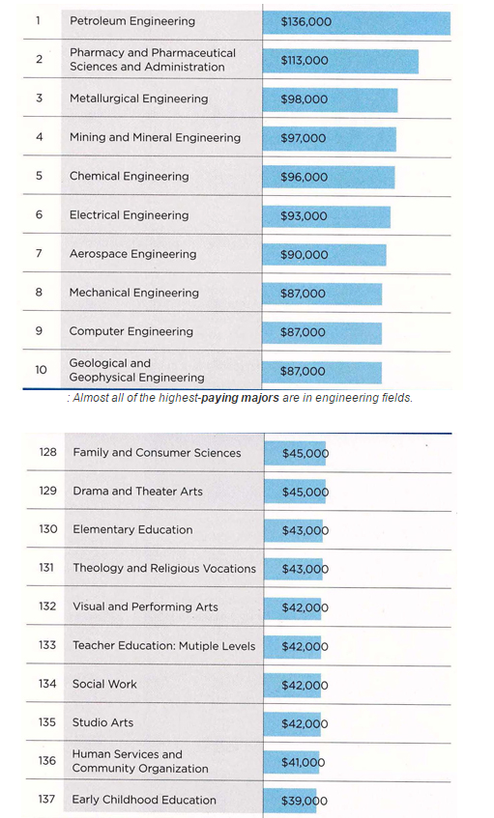
The lowest-paying majors are in education, arts, and social work fields. SOURCE: GEORGETOWN UNIVERSITY CENTER ON EDUCATION AND WORKFORCE

