Megan Rees
Final Exam - Version B

Exploring Business & Marketing Final Exam
BUSINESS BASICS

1. When there is more demand than supply you have:
- Opportunity Cost
- Scarcity
- Supply
- Demand

2. A benefit, profit, or value of something that must be given up to acquire or achieve something else.
- Opportunity Cost
- Scarcity
- Supply
- Demand

3. The amount of goods and services that producers will provide at various prices.
- Opportunity Cost
- Scarcity
- Supply
- Demand

4. The amount or quantity of goods and services that consumers are willing to buy at various prices.
- Opportunity Cost
- Scarcity
- Supply
- Demand

5. Goods made and used to produce other goods and services. Examples include buildings, machinery, tools and equipment.
- Capital Resource
- Human Resource
- Natural Resource
- Supply

6. The people employed in a business, commonly referred to as personnel. Work together to make goods and services:
- Capital Resource
- Human Resource
- Natural Resource
- Demand
7. Raw materials from nature used to produce goods.
- Capital Resource
- Human Resource
- Natural Resource
- Scarcity

8. License giving the sole right to exclude others from making, using, or selling an invention
- Patent
- Copyright
- Trademark
- Resource

9. Words or symbols that are legally owned
- Patent
- Copyright
- Trademark
- Resource

10. The legal right to be the only one to reproduce, publish, or sell the contents and form of a literary, musical, or artistic work
- Copyright
- Trademark
- Patent
- Resource

11. A business owned by only one person.
- Sole Proprietorship
- Corporation
- Partnership
- Goods and Services

12. A legal form of business operation between two or more individuals who share management and profits.
- Sole Proprietorship
- Corporation
- Partnership
- Goods and Services

13. A company or group of people authorized to act as a single entity (legally a person) and recognized as such in law.
- Sole Proprietorship
- Corporation
- Partnership
- Goods and Services

14. The rules of moral conduct governing an individual or a group.
- Ethics
- Economics
- Scarcity
- Demand

15. The image below is an example of:

- Trademark
- Patent
- Copyright
- Economics

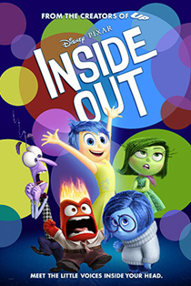
16. The image below is an example of:

- Trademark
- Patent
- Copyright
- Economics

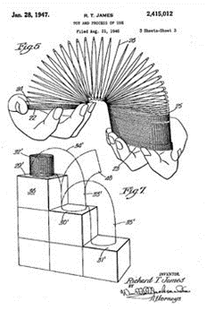
17. The image below is an example of:

- Trademark
- Patent
- Copyright
- Economics

MARKETING
18. When consumers buy products because they feel a sense of loyalty to the company, store, or brand.
- Personal Selling
- Patronage Motivation
- Market Research
- Market Segmentation
19. The process of planning, pricing, promoting, selling, and distributing ideas, goods, and services.
- Mass Media
- Personal Selling
- Product
- Marketing
20. Facts about the population, including age, gender, location, and income.
- Advertising Media
- Direct Marketing
- Advertising
- Demographics
21. What makes consumers want to purchase or buy a company’s goods or services?
- Consumer Motivation
- Demographics
- Direct Marketing
- Logo

22. When marketing companies use arguments that are convincing but not necessarily valid
- Direct Marketing
- Social Media
- Advertising
- Propaganda Techniques
23. Simple and catchy phrase accompanying a logo or brand.
- Slogan
- Survey
- Sales Promotion
- Target Market

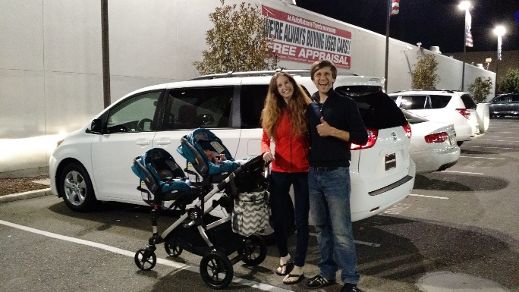
24. What is the motivation behind this purchase (Minivan)?
- Emotional
- Price
- Patronage
- Rational

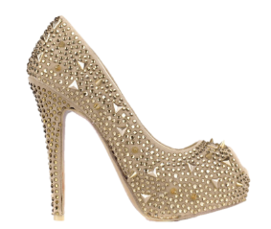
25. What is the motivation behind this purchase (Shoe)?
- Emotional
- Price
- Patronage
- Rational

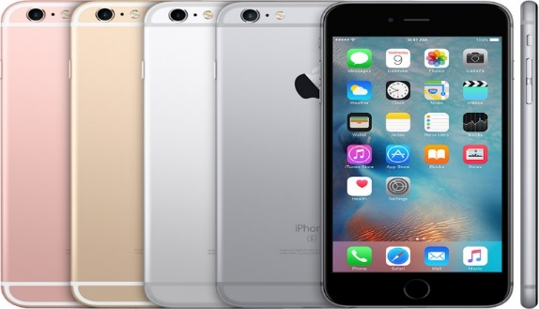
26. This is an example of (Iphone)?
- Product
- Price
- Place
- Promotion

27. This is an example of (advertisement)?
- Product
- Price
- Place
- Promotion

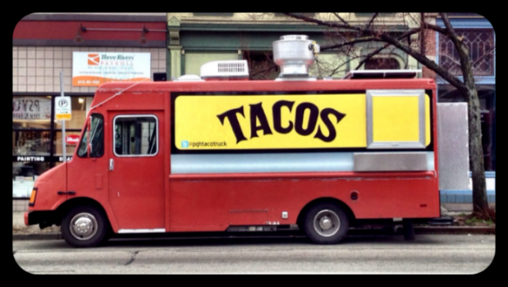
28. This is an example of (Food Truck)?
- Product
- Price
- Place
- Promotion

29. Segmenting a market based on where customers live
- Market
- Geographic
- Segmentation
- Demographics

30. Dividing a market based on mental and emotional characteristics of customers.
- Psychographic
- Geographic
- Segmentation
- Demographics

ACCOUNTING
31. What is the accounting equation?
a. Assets=Liabilities x Equity
b. Assets=Liabilities+Equity
c. Assets=Liabilities – Equity
d. Liability=Assets/Equity
32. Which of the following is an Asset?
a. A loan
b. A mortgage
c. A House
d. medical bills
33. A balance sheet shows financial information
a. over a set amount of time—usually a quarter
b. at a certain date—it shows the current situation as of the day generated
c. before and after—it shows the situation before a budget and after a budget
d. In advance – it shows the situation before the money is spent
34. Ella buys a house for $600,000. She puts $200,000 down in cash, and the rest she takes out a loan. What does her balance sheet look like?
 | Assets | Liabilities | Equity
A | $600,000 | $400,000 | $200,000
B | $400,000 | $600,000 | $200,000
C | $200,000 | $400,000 | $600,000
D | $600,000 | $200,000 | $400,000

35. Which of these is in order of liquidity, from most liquid to least?
a. House, Stocks, Accounts Receivable, Cash
b. House, Stocks, Cash, Accounts Receivable
c. Stocks, Cash, Accounts Receivable, House
d. Cash, Stocks, Accounts Receivable, House

STOCK MARKET
36. A sum of money paid regularly by a company to its shareholders out of its profits.
- Interest
- Compound Interest
- Dividends
37. Which of the following is a diverse Portfolio?
a. Portfolio A

b. Portfolio B

38. Stocks can be described as:
- Ownership
- An IOU
- Collection

39. A collection of financial assets:
- Stock
- ROI
- Dividend
- Portfolio
40. When interest starts to earn it’s own interest, it’s called ____________ interest
- Compound
- Higher
- Earing
- Net Average Earnings
41. Money that is owed or due?
- Income
- Real Estate
- Debt
- Stocks
42. AAPL, K, and NFLX are all examples of:
- Companies
- Ticker symbols
- Counter measures
- Shorthand names
43. When a market is high and people are buying, it is called a _____________ market.
- Bear
- Bull
- Rabbit
- Turtle
44. When a market is low and people are selling, it is called a _____________ market.
- Bear
- Bull
- Bunny
- Boar

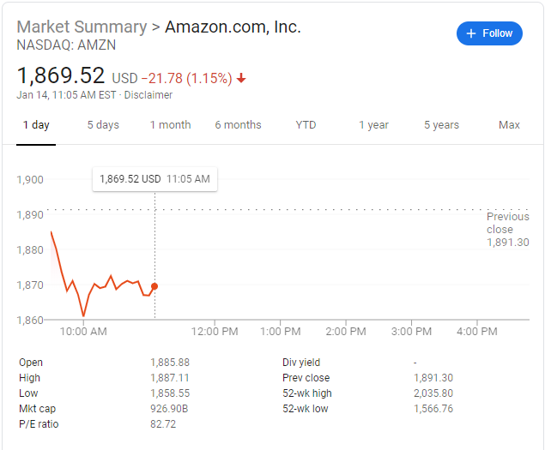
45. In the chart, what is the stock trading at right now?
a. $1885.88
b. $1869.52
c. $926.90
d. $1891.30
46. In the chart, what is the yearly low for this stock?
a. $1858.55
b. $1887.11
c. $1869.52
d. $1566.76

