Megan Rees
Final Exam Version A

Exploring Business & Marketing Final Exam
STOCK MARKET
1. A sum of money paid regularly by a company to its shareholders out of its profits.
- Interest
- Compound Interest
- Dividends
2. Which of the following is a diverse Portfolio?
a. Portfolio A

b. Portfolio B

3. Stocks can be described as:
- Ownership
- An IOU
- Collection

4. A collection of financial assets:
- Stock
- ROI
- Dividend
- Portfolio
5. When interest starts to earn it’s own interest, it’s called ____________ interest
- Compound
- Higher
- Earing
- Net Average Earnings
6. Money that is owed or due?
- Income
- Real Estate
- Debt
- Stocks
7. AAPL, K, and NFLX are all examples of:
- Companies
- Ticker symbols
- Counter measures
- Shorthand names
8. When a market is high and people are buying, it is called a _____________ market.
- Bear
- Bull
- Rabbit
- Turtle
9. When a market is low and people are selling, it is called a _____________ market.
- Bear
- Bull
- Bunny
- Boar
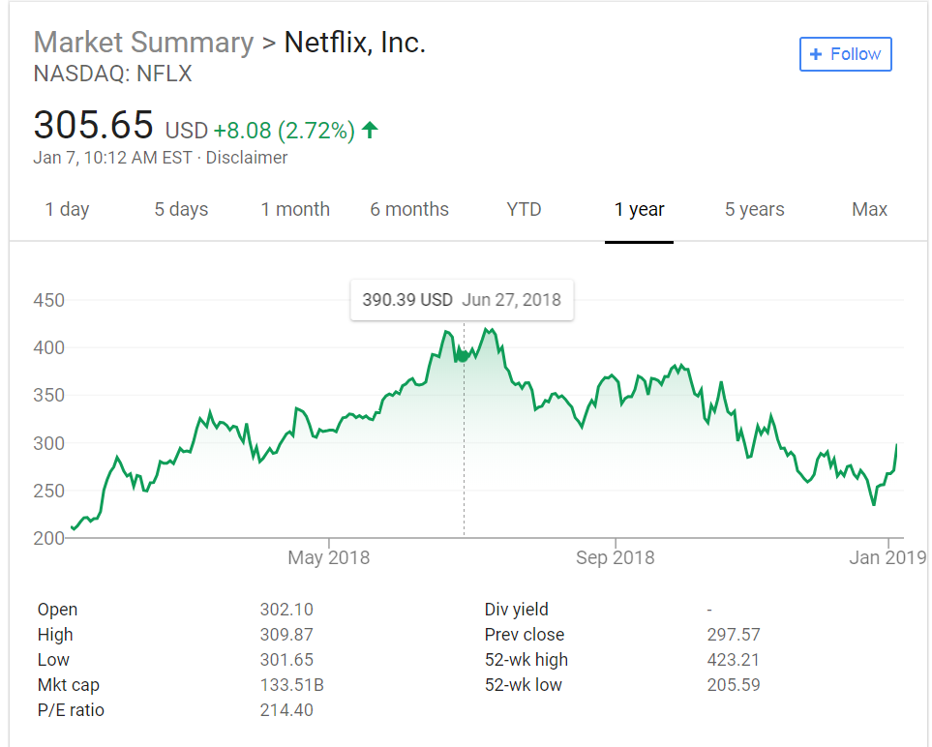
10. In the chart, what is the stock trading at right now?
a. $305.65
b. $298.57
c. $301.65
d. $423.21
11. In the chart, what is the yearly high for this stock?
a. $302.10
b. $423.21
c. $205.59
d. $305.65
ACCOUNTING
12. What is the accounting equation?
a. Assets=Liabilities x Equity
b. Assets=Liabilities+Equity
c. Assets=Liabilities – Equity
d. Liability=Assets/Equity
13. Which of the following is an Asset?
a. A loan
b. A mortgage
c. Medical bills
d. A house
14. A balance sheet shows financial information
a. over a set amount of time—usually a quarter
b. at a certain date—it shows the current situation as of the day generated
c. before and after—it shows the situation before a budget and after a budget
d. In advance – it shows the situation before the money is spent

15. Travis buys a house for $400,000. He put’s $100,000 down in cash, and the rest he takes out a loan. What does his balance sheet look like?
 | Assets | Liabilities | Equity
A | $300,000 | $100,000 | 0
B | $400,000 | $300,000 | 0
C | $400,000 | $300,000 | $100,000
D | $300,000 | $100,000 | $400,000

16. Which of these is in order of liquidity, from most liquid to least?
a. House, Stocks, Accounts Receivable, Cash
b. House, Stocks, Cash, Accounts Receivable
c. Stocks, Cash, Accounts Receivable, House
d. Cash, Stocks, Accounts Receivable, House
MARKETING
17. When consumers buy products because they feel a sense of loyalty to the company, store, or brand.
- Personal Selling
- Patronage Motivation
- Market Research
- Market Segmentation
18. The process of planning, pricing, promoting, selling, and distributing ideas, goods, and services.
- Mass Media
- Personal Selling
- Product
- Marketing
19. Facts about the population, including age, gender, location, and income.
- Advertising Media
- Direct Marketing
- Advertising
- Demographics

20. What makes consumers want to purchase or buy a company’s goods or services?
- Consumer Motivation
- Demographics
- Direct Marketing
- Logo

21. When marketing companies use arguments that are convincing but not necessarily valid
- Direct Marketing
- Social Media
- Advertising
- Propaganda Techniques
22. Simple and catchy phrase accompanying a logo or brand.
- Slogan
- Survey
- Sales Promotion
- Target Market

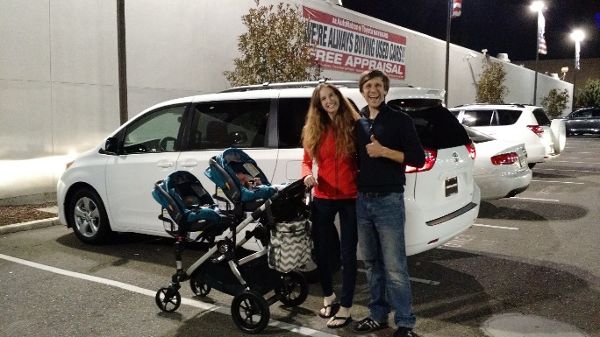
23. What is the motivation behind this purchase (Minivan)?
- Emotional
- Price
- Patronage
- Rational

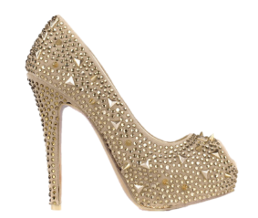
24. What is the motivation behind this purchase (Shoe)?
- Emotional
- Price
- Patronage
- Rational

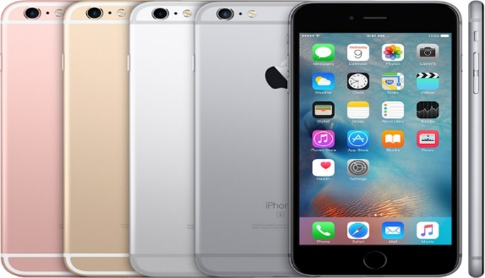
25. This is an example of (Iphone)?
- Product
- Price
- Place
- Promotion

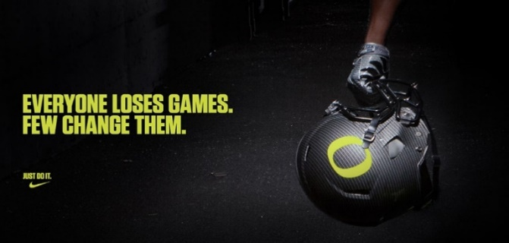
26. This is an example of (advertisement)?
- Product
- Price
- Place
- Promotion

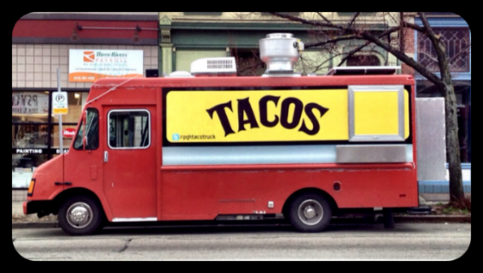
27. This is an example of (Food Truck)?
- Product
- Price
- Place
- Promotion

28. Segmenting a market based on where customers live
- Market
- Geographic
- Segmentation
- Demographics

29. Dividing a market based on mental and emotional characteristics of customers.
- Psychographic
- Geographic
- Segmentation
- Demographics

BUSINESS BASICS

30. When there is more demand than supply you have:
- Opportunity Cost
- Scarcity
- Supply
- Demand

31. A benefit, profit, or value of something that must be given up to acquire or achieve something else.
- Opportunity Cost
- Scarcity
- Supply
- Demand

32. The amount of goods and services that producers will provide at various prices.
- Opportunity Cost
- Scarcity
- Supply
- Demand

33. The amount or quantity of goods and services that consumers are willing to buy at various prices.
- Opportunity Cost
- Scarcity
- Supply
- Demand

34. Goods made and used to produce other goods and services. Examples include buildings, machinery, tools and equipment.
- Capital Resource
- Human Resource
- Natural Resource
- Supply

35. The people employed in a business, commonly referred to as personnel. Work together to make goods and services:
- Capital Resource
- Human Resource
- Natural Resource
- Demand
36. Raw materials from nature used to produce goods.
- Capital Resource
- Human Resource
- Natural Resource
- Scarcity

37. License giving the sole right to exclude others from making, using, or selling an invention
- Patent
- Copyright
- Trademark
- Resource

38. Words or symbols that are legally owned
- Patent
- Copyright
- Trademark
- Resource

39. The legal right to be the only one to reproduce, publish, or sell the contents and form of a literary, musical, or artistic work
- Copyright
- Trademark
- Patent
- Resource

40. A business owned by only one person.
- Sole Proprietorship
- Corporation
- Partnership
- Goods and Services
41. A legal form of business operation between two or more individuals who share management and profits.
- Sole Proprietorship
- Corporation
- Partnership
- Goods and Services

42. A company or group of people authorized to act as a single entity (legally a person) and recognized as such in law.
- Sole Proprietorship
- Corporation
- Partnership
- Goods and Services

43. The rules of moral conduct governing an individual or a group.
- Ethics
- Economics
- Scarcity
- Demand

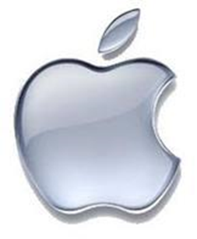
44. The image below is an example of:

- Trademark
- Patent
- Copyright
- Economics

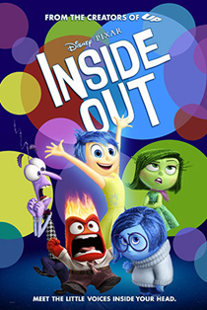
45. The image below is an example of:

- Trademark
- Patent
- Copyright
- Economics

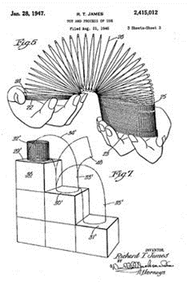
46. The image below is an example of:

- Trademark
- Patent
- Copyright
- Economics

