Staycation Explanation
Billboard

- Choose a colored poster board for your billboard—you can find them on the back table in my room.
- Lettering
  - If you want Mrs. Rees to cut out your title lettering, first choose which font you want to use.
    - Go to Word, type in the word you want, and try lots of different fonts until you choose on.
    - Remember that the word will be cut out of paper. So fonts with lots of distressing on it won’t work.
    - Come see Mrs. Rees.
    - Pick a colored piece of construction paper from the pile by her desk.
    - Be sure to pick a color that highly contrasts your poster paper.
    - Tell Mrs. Rees your font and your word and she will cut it for you.
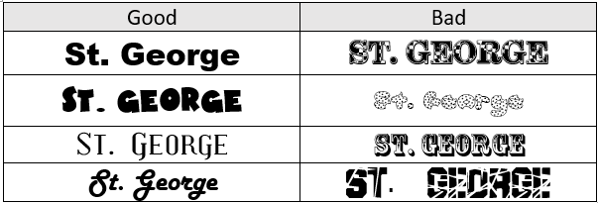
    - When it’s complete, she will call you over to pick it up. If it’s toward the end of class, ask for a paperclip so you can attach the letters to your posterboard until you are ready to glue them on.
  - If you want to do your own lettering, you can either write it on with marker or you can print it out from word and paste it on.
- Images
  - Find images online and copy and paste them into word. Then print.
- Wording
  - Type your wording up in Word. Choose different fonts and colors.
  - If you want to print on colored paper, let Mrs. Rees know and we can work that out.
  - Print and cut them into the shapes you need.
- Logo & Slogan
  - Make sure to include your logo and slogan, as it’s required!
- Putting it together
  - On the back table there is two kinds of glue—rubber cement and glue stick. Use glue tick for lettering and rubber cement for everything else.
  - If your letters are particularly delicate (a thin, loopy font for example) talk to Mrs. Rees about getting sticky put on the back with her special machine.
- Storage
  - At first you can store your poster on the top of the tall file cabinet in Mrs. Rees’ room.
  - At any point—even before it’s finished—you can put Velcro on it and put it up on the wall. There is a cup with squares of Velcro on the table for this purpose—one on each corner. PLEASE THROW AWAY THE PART YOU PEAL OFF!!!
- Names
  - Make sure you have written your team number on the back—not on the front.

