Warmup #1 – Home Row
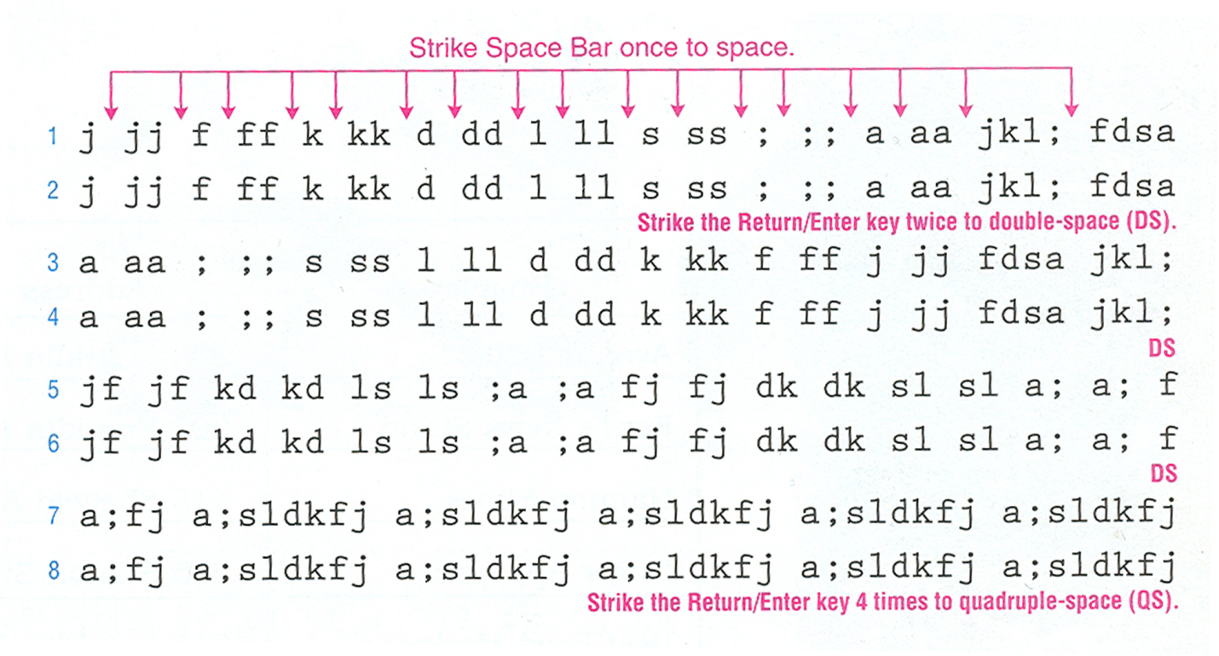
Type 3x or until time
Warmup #2 – Home Row
Type 2x or until time
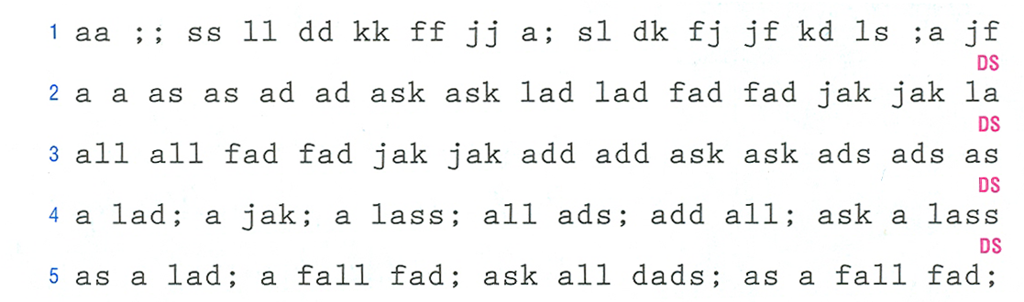
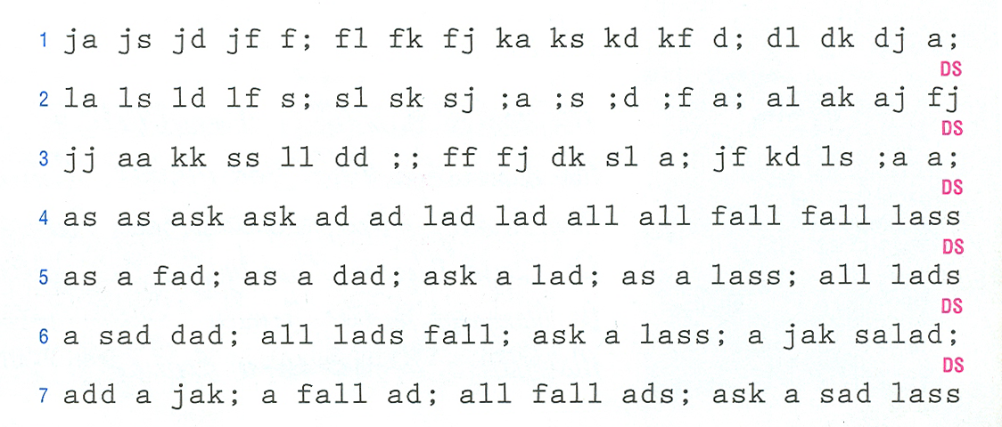
Warmup #3 – H, E, T

j j hj hj ah ah ha ha had had has has ash ash hash
hj hj ha ha ah ah hah hah had had ash ash has hash
ah ha; had ash; has had; a hall; has a hall; ah ha

d d ed ed el el led led eel eel eke eke ed fed fed
ed ed el el lee lee fed fed eke eke led led ale ed
a lake; a leek; a jaek; a desk; a jade eel; a deed

ftf ftf tale set tall sat jhj has hal teh aha dead
fad tod ted teal lad salad tall tell sat had a tas
tate that teeth teek keet let the tale had lad the

Warmup #4 – O, R, N

o o oo lo ol lo ol lol olo ole old dode ede hot otes oaks
ol lo ol ko ;o o; jo oj joe fo do so ao oae doe foes oje;
old ola; holes hots tots told held toll shoes sells folds

r r rr fr rf fr ra fr tf ftr rft atr tar dear reat treats
fr rf ar fro for doj kot tor ret tear teek kort hort tors
fff rrr ttt aaa ddd rrr rd ra re rh rk rl r; ro role door

n n nn jn nj jjj nnn jn jn nj jh jhn nh hn kon jon not to
jon jlk klk ;j; ajk ajo okd jfh hjj jnn jan fan dan notes
flan dean need nerd jone forn arn nore snake note rho ron

Warmup #5 – Review

states hands drones hates shed heather jets loser arms to
rated fate hated strand shore loose shade stand at hotter
fell off she told not to rolled dad asked raked send sent

heard off send dent he ate lads ask for the hands off san
solo had sad lad dad stare flare hare odd fodder nod trad
fane rane dane torn horn forlorn shorn forn thorned hands

hand send that lend off sands thorn shore drone jet loser
hat karate lose shorn store stone notes horned send hotts
fran sate rate hate state late sent rake fake stake lakes

Warmup #6 – M, C, Left Shift

m mm mj jm mj mjm jmj jnm mnj hm hm nhn mjm jhm mmm jjj m
jam jan jam jan hand man demand moan mean raft room manke
jams looked made mom mar mare foam dome some make matters

c cc dc cd edc cde dce dec dcfr dcrf sc ca ac rc tc ctr c
cat can catch come cancer cater candor candle cake ace ca
coo date farm carrot cannot deck tack stack case creed co

Hal Heather Jason Lana Kelsie John Nathan Mara Harold Lou
Johnson Omar Jenneka Lake Nora Maressa Nell Morrison Jenn
Lands; Lee; Karen; Jesse; Kalee; Leanna; Norman; Jose; Ke

Warmup #7 – I, . , Right Shift

i ii ki ik kid kids kiik iikk kk ii like rite ill isle io
ilk ink oink oil irish irk in out mite fit is site
Indiana irritate Ira did it is in Hailie Molli sit

.. .l l. .l. .l. ol. ol. load. jail. ill. l.. .oo.
fl. ft. hr. ed. rd. rt. off. fed. ord. alt. asstd.
this. is. the. end. Lake. Jillian. Mark. Jan. Hal.

A; A; Al Al; Cal; Ali Ali or Flo; Di and Sol left.
Ali lost to Ron; Cal lost to Elsa; Di lost to Del.
Tina has left for Tucson; Dori can find her there.

Warmup #8 – Review

In the end this is hard. No one said this is mine.
I can hear the jokes told in the other three rooms.
Odd food can make one feel sick. Do not eat that.

Take notes for me and I can do it another time ok.
She asked for a roll; then Janetta ate it first.
Dr. Loren said that she can do nine jacks at first.

The farm is located on the north side of the track.
The ranch is found to the east of the lake for Jane.
The race is to start soon; Jerri can run faster.

Warmup #9 - , U CAPS

k k ,k ki, kit; Rick, Mike, Ike, or I can do, also.
A ski, a ski; a kit, a kit; a kite, a kite; a like,
Ike, I see, is here; Cam and Jo cannot make it.

j j uj uj us us dun just june jut due due fur furs.
uj uj juri jur sue sued lune use use dues mud tues.
due rue june nau cue cure luck coat use fuss cutes.

Did he join a CNA firm? I can join NASA if Jon can.
Her dad is a CEO at HLRA. Alisha is a CDA at DILKD.

Warmup #10 – B,P,W

f f bf bf fib fib rob rob but but bit bit fib fibs
bf bf rob rob lob lob orb orb bid bid bud bud ribs
a rib; to fib; rub it; an orb; or rob; but she bid

; ; p; p; pa pa up up apt apt pen pen lap lap kept
p; p; pa pa pa pan pan nap nap pat pat put put rap
a pen; a cap; apt to pass; pick it up, plan to sit

s s ws ws sow sow wow wow low low how how cow cows
sw sw ws w sow ow now now row row own own tow tows
to sow, is how. So low; to own. Too low; is to row.

Warmup #11 – Review

swan turtle fish duck cat lion skunk koala snakes.
I can use this pen if it is ok with Jen. Its hers.
This is a stupid and lame sentence but write it.

Joanna likes to crochet little doilies in her room.
Mr. Monson went to see if the doctor was returned.
If Peri wants to join the NRA he can come tomorrow.

Joselin wants to learn Spanish or French this time.
Connecticut, Deleware, Indiana, Montana, Louisiana.
Smiles can make people more inclined to smile too.

Warmup #12 – Review
Sometimes we walk to the cabin on nice afternoons.
dance run scream escape allow chase work promises.
narrow thankful calm tasteless nutritious abundant

plastic sister shop plantation recess reward pears
water partner seashore flood education summer wren
wheel sweater wilderness coach doll kite jar horse

Jose went to the store last week to bet on the win.
We went to Sweet Creek to see if Mellanie was back.
In the winter we curl up near the fire to get warm.

Warmup #13 – G : Q

g gg gf fg gff fgg ftg gtr frtg gfgf hg jfhg greda
great grand gold gorgeous gaunt game gale grind go
elegant egregious agoraphobic eggplant igloo grins

q qq aq qa qa aqa qaq aqua aqs wsq dsq saq qas sqf
quote queen quill equipment quit quiet quilt quart
Queen Quinn quoted the quiet quilter in quotations.

; ; ;: :; :; ;: Date: Time: Name: Room: From: File:
;: :; To: File: For: to: Dear Al: Shift for: Sine:
Michella, use as headings: To: From: Date: Subject:

Warmup #14 – g,/,?

f f vf vf via via vie vie have have five five live
vf vf vie vie vie van van view view dive dive jive
go via; vie for: has vim; a view, to live: or have

; ; /; /; ;;// ;/; ;/; this/that here/there /;/ /;
/?/ ??? /// ??? ;/ ;? /: ?: ;/ :? ;/ ;? ;? ;// :??
Never no never? Love/War How?? When? Where? If?

Vera. Varushka; Victor: Vannah? Vespa, Vilimi. Vi.
The vicious and vain vela, Virginia, loved violets.
Violet is Violent: Vladimir is villainous. Voila.

Warmup #15 – Review

Whenever Harold comes to town, Ellie gets nervous.
The answer is apparent: Wendi is not going to win.
Go to www.howdoesitwork.com to find the answers.

Virgil plans to find that mosque at two with Jack.
Pam, Van, and Quin have to be in New Hope at five.
Vi is to aid the girl with the sign work at eight.

Jim and Kate are going to Las Vegas all this week.
Mrs. Maria Fuentes; Dr. Mark V. Quin; Mr. T.C. Ott
Mae has a Ph.D. from Miami; Don will get his Ed.D.

Warmup #16 – X,Y,Z

x xx xs sx xsw wsx wsx wax axe axel exe ex ax taxi
explore extra excellent excels fix fox ox lax flex
a fox; an ox: mix it; fax it: six men. Max can fix.

y yj jy hy hy yj jyh ny my hay may nay shy day way
yj yj jay jay eye eye dye dye yes yes yet yet jays
a jay; to say; and eye: he says; dye it; has an eye

a a za za zap zap zap zoo zip zip zag zig zag zany
za za zap zap zed zed oz. oz. zoo zoo zip zip maze
zap it, zip it, and adz, to zap, the zoo, eight oz.

Warmup #17 – Review

Why are JoAnne and Marietta both getting vexed now?
We can fix the zeppelin if we can get Max to help.
I saw a zebra at the zoo and, yes, it was striped.

xsx :; fix mix Max: Use TO: and FROM: as headings.
Qa .k aqa k.k quo quo, quit, aqua. Quite squat vow
Zosha was quick to dive into my big pool for Jinx.

Ian kept a pen and work forms handy for all of us.
Type these ZIP Codes: OR, MD, RI, NV, AL, and PA.
He may go to the lake by dusk to do the dock work.

Warmup #18 – Review

Jan may go to the city for the bid forms for them.
I did all the work for the firm for the usual pay.
Did Ms. Paxon send us the letter from Dr. LaRonde?

as my we in be on at up as no are him way you gets
girl quay turn rush duty down maps rich laid spend
if they to risk by them the duty and paid she kept

Olga sews aqua and red silks to make six big kites.
Bob Epps lives in Rome; Vick Copa is in Rome, also.
Oatsie and Co. has a branch office in Boise, Idaho.
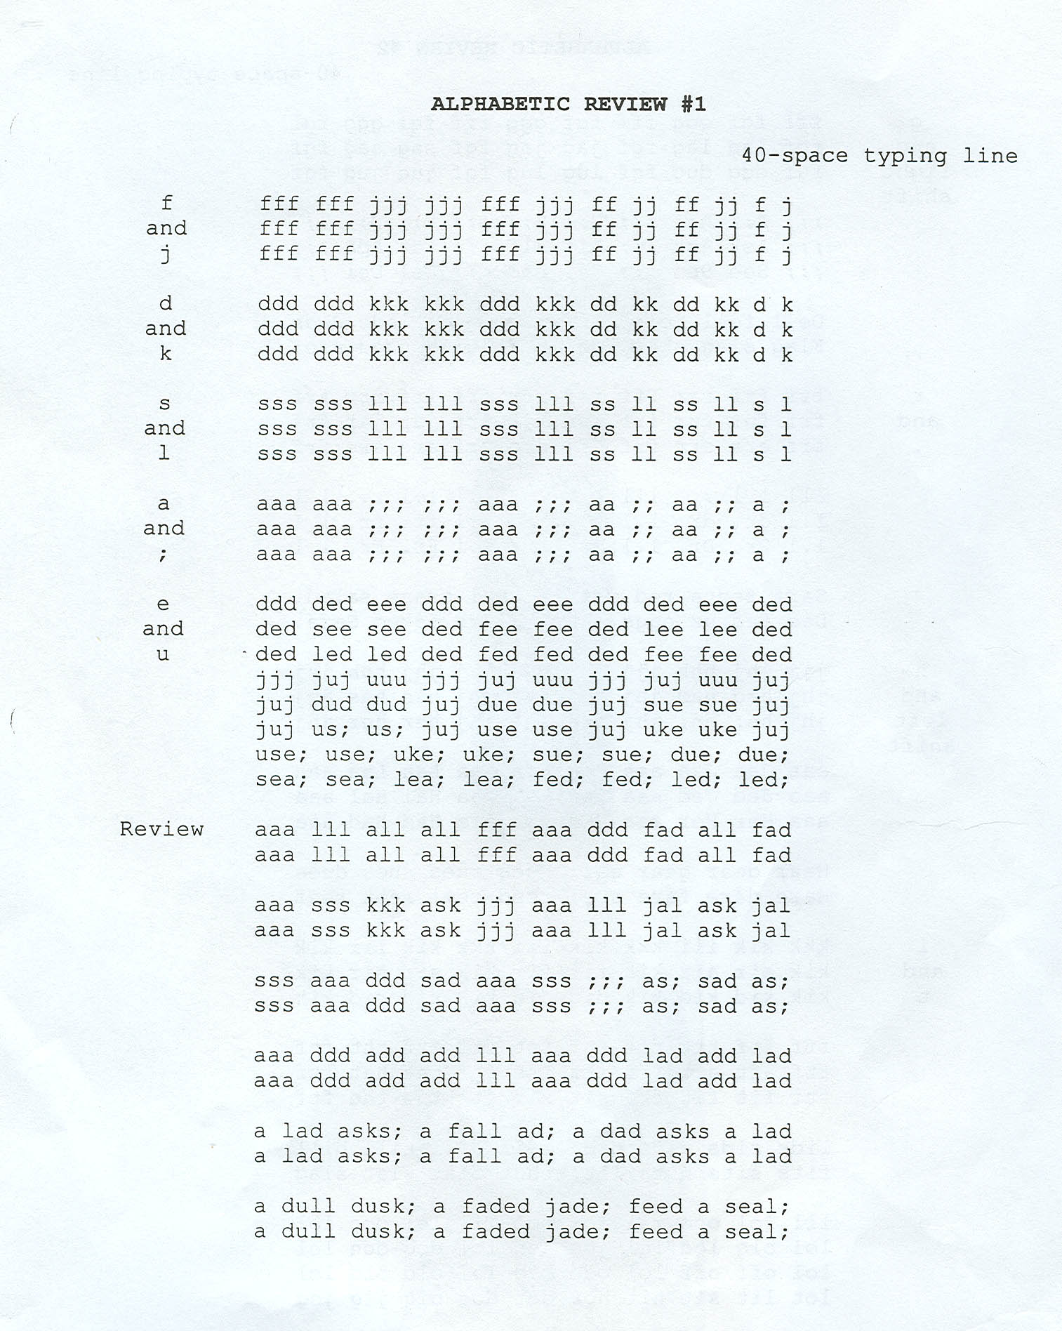
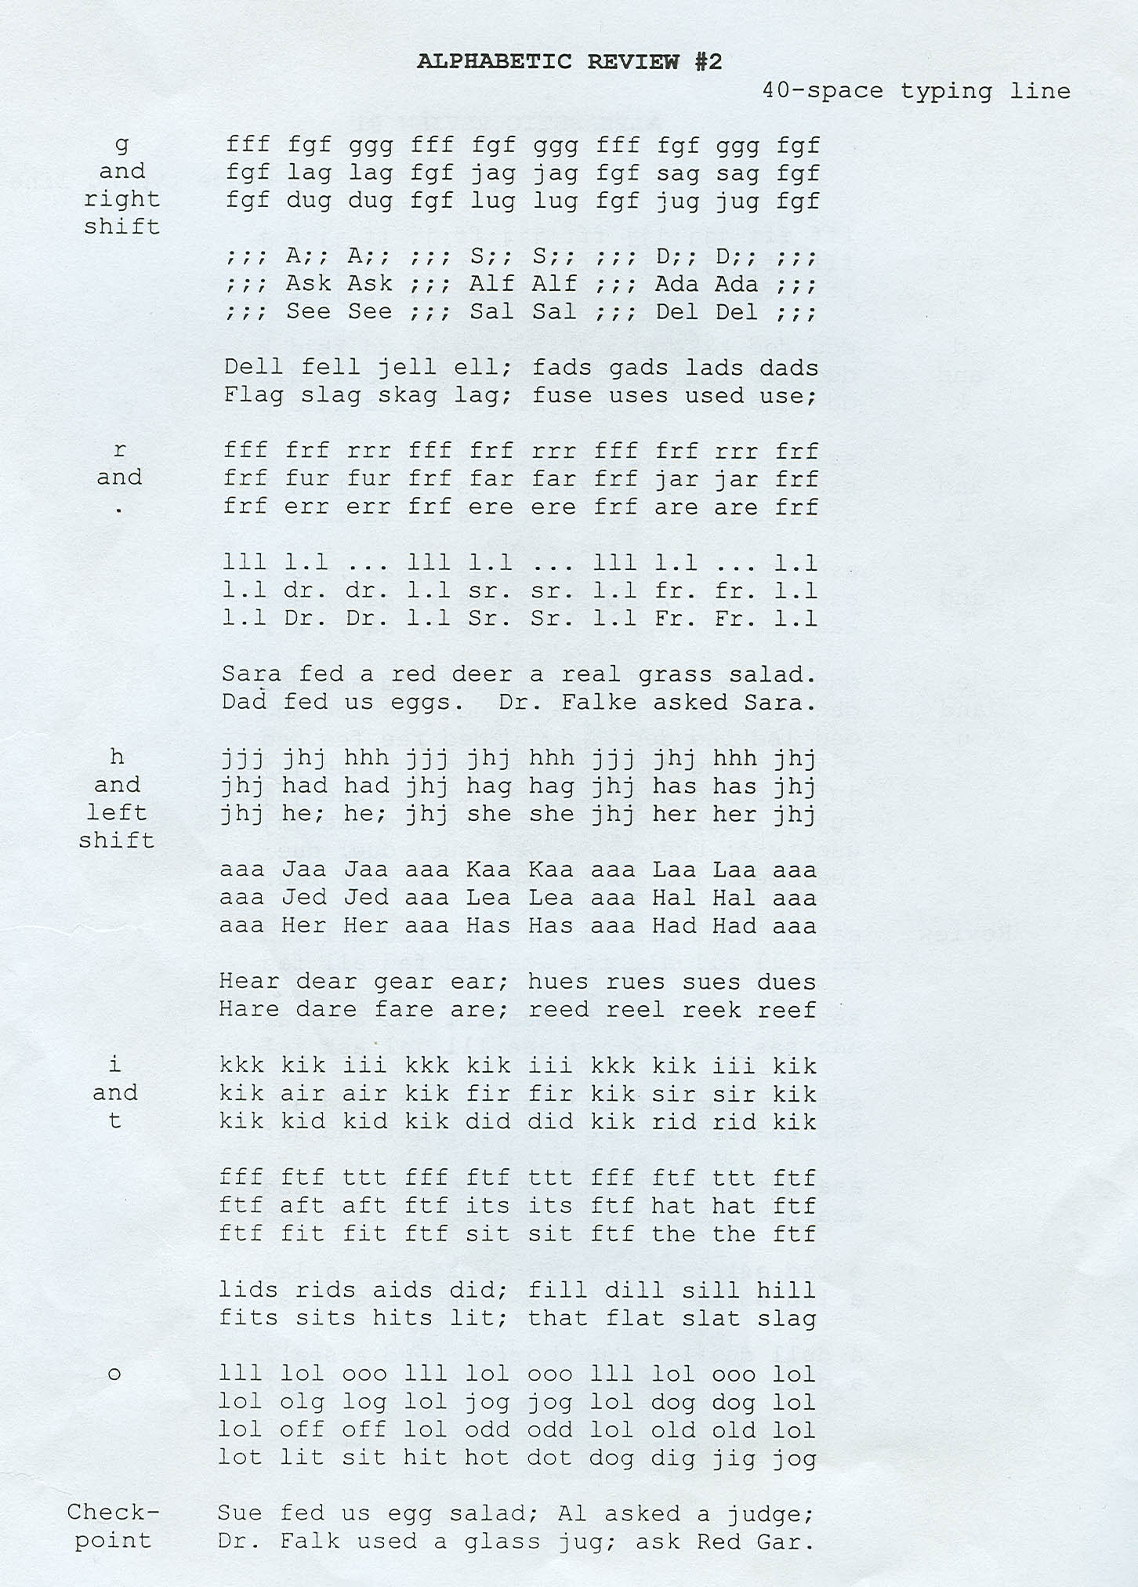
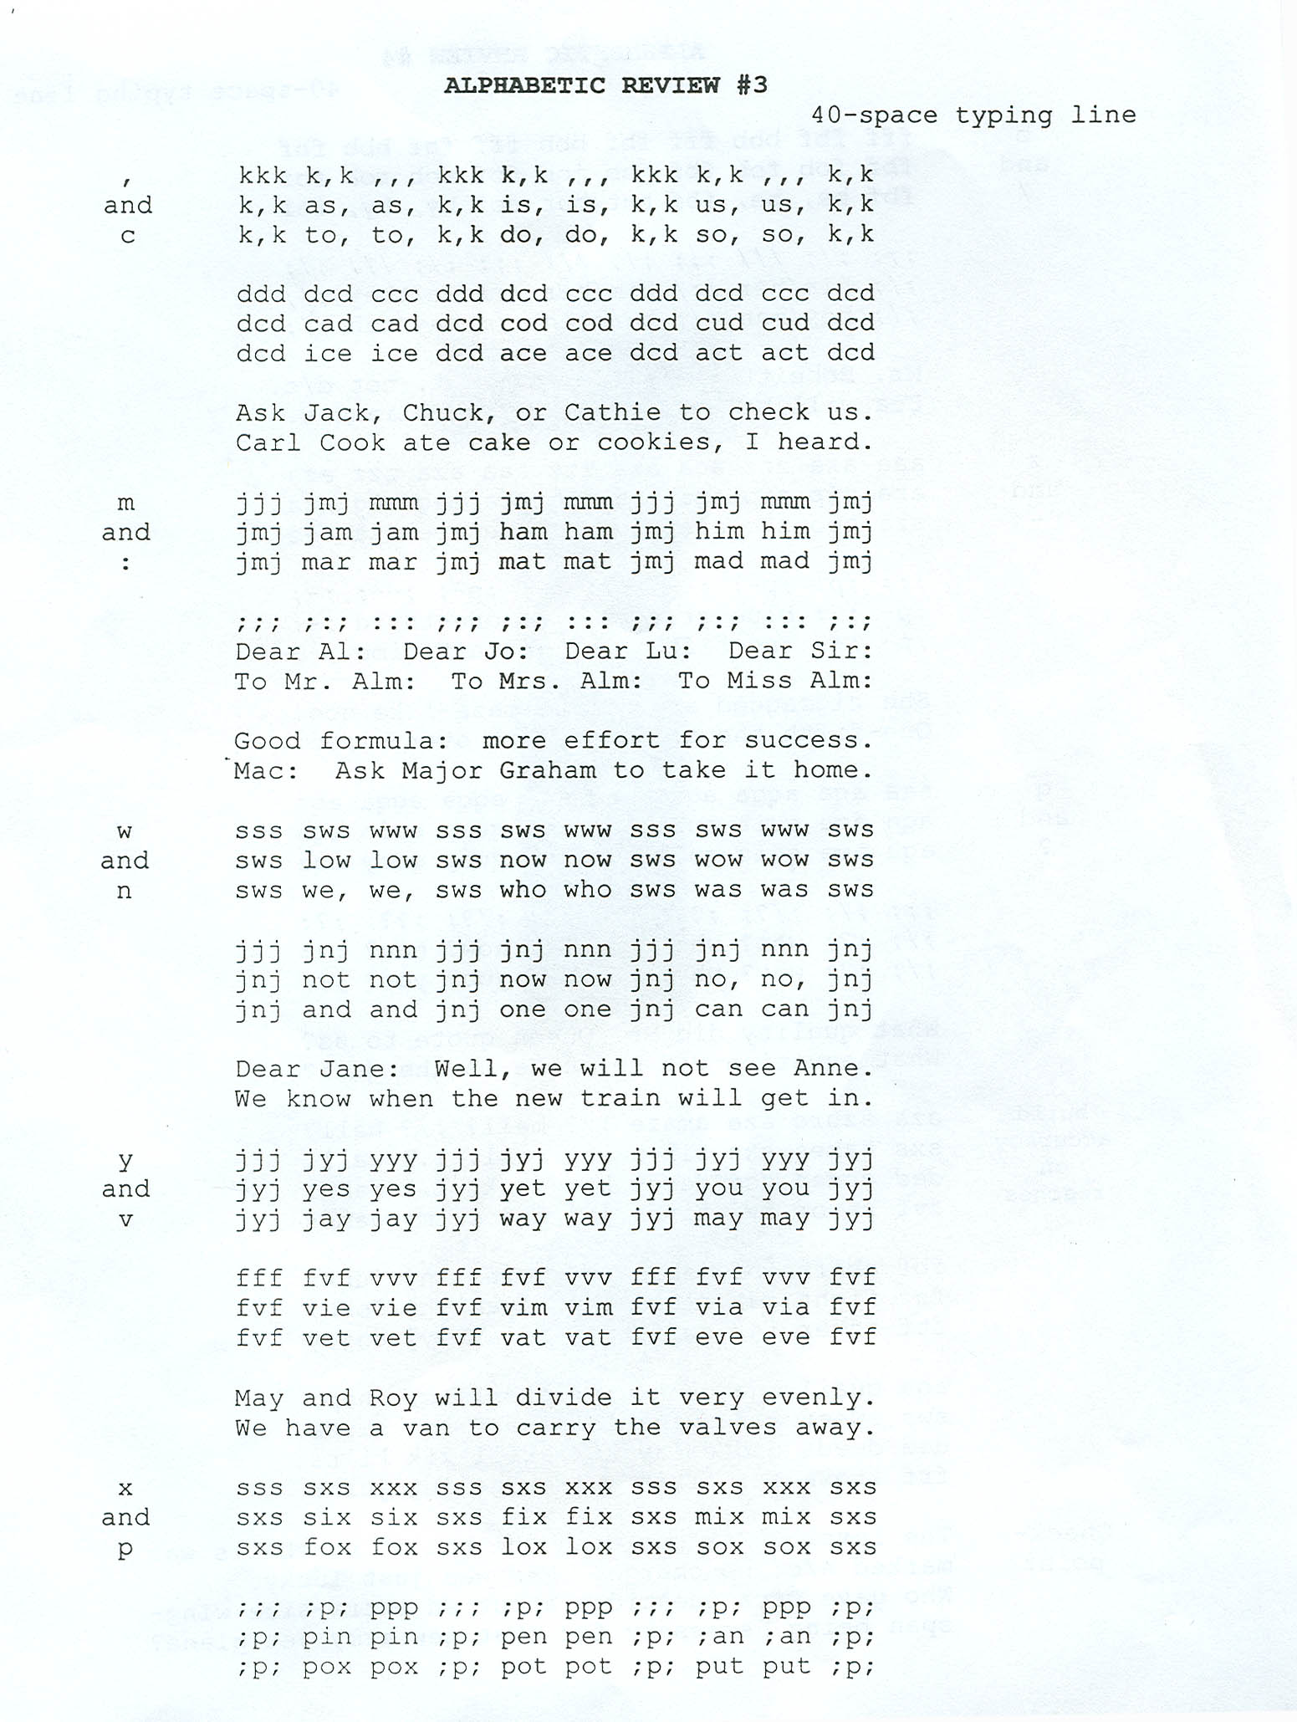
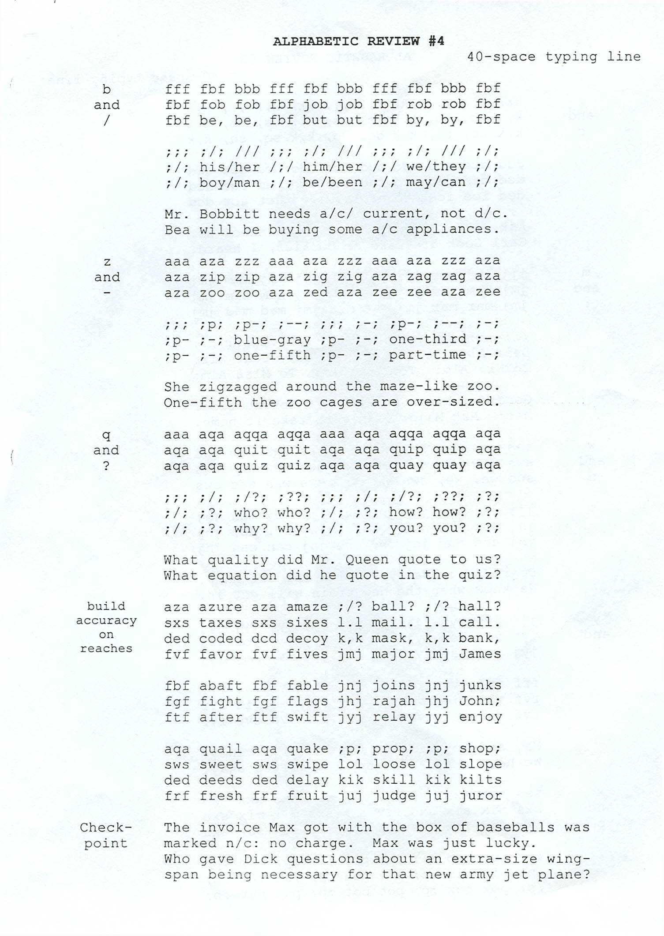
ALPHABETIC REVIEW #5

1&2 1 aq1a a11a a11a a1a1 a1a1 a1a1 a11 111 and 111, 111
2 11 arts 11 axes 11 aims 11 alms 11 aces 1, 11 1:11
3 We need 11 pairs of size 11 shoes for the 11 men.

4 sw2s sw2s s22s s22s s2s2 s2s2 a11 222 and 112, 122
5 22 sons 22 sums 22 seas 22 sips 22 suns 2.22 2:22
6 The 12 men and the 22 boys played 122 full games.

7 of the 122 who paid, only 11 or 123 were children.
8 About 112 caught the 12:12 train on Track No. 21.

3&4 9 de3d de3d d33d d33d d3d3 d3d3 a11 333 and 123, 123
10 33 dads 33 dips 33 dues 33 dots 33 dogs 3.13, 3:13
11 Did the 3 men catch 31 or 33 fish in the 13 days?

12 fr4f fr4f f44f f44f f4f4 f4f4 a11 444 and 123,441
13 44 furs 44 fins 44 fish 44 fell 44 flew 4.14 4:14
14 The 44 boys lost only 14 of their 144 golf games.

15 1. Of the 43 persons attending, 34 placed orders.
16 2. The orders of the 34 came to about 112 pounds.

5&6 17 ft5t ft5t fr5r fr5r f55f f55f r5r r5f a11 555 155.1
18 55 rings 55 rhubarb 55 rams 55 runs 5.55, 45.5, 4:5
19 Ruth got 51 bee stings, 55 bites and 524 calls home.

20 fg6 fg6g fg6g g6g6 g6g6 66gg 666 s22 g6g 6.66 116.6
21 66 girls 66 grins 66 gills 66 gates 66 gripes 61:61
22 Janey wears number 66. She got 16 throws and made 6.

23 Of 56 students, 45 keyed at least 35 wpm by April 18.
24 Can you meet at 1556 Maple Ave. at 5:16 p.m. today?

7&8 25 ju7j ju7j j77j j77j j7j7 j7j7 you 777 for 123,477
26 77 jugs 77 jars 77 jigs 77 jets 77 jobs 7/17 7:17
27 on june 7, the 7 men left Camp 7 on the 7:17 bus.

28 ki8k ki8k k88k k88k k8k8 k8k8 irk 888 for 123,567
29 88 kits 88 keys 88 kids 88 inks 88 ins 8/18 8:18
30 Train No. 188 departs at 11:88 a.m. or 12:18 p.m.

31 Of the 178 who paid, only 37 o4 38 were children.
32 About 187 caught the 12:17 train on Track No. 18.
9&0 33 1091 1091 1991 1991 1919 1919 a11 999 for 234,789
34 99 lots 99 lids 99 laws 99 logs 99 less 1/19 9:19
35 In 1919, there were 199 men in each of the 19 lodges.

36 ;p0; ;p0; ;00; ;00; ;0;0 ;0;0 lop 000 for 347, 890
37 10 pegs 10 pins 10 play 10 paid 10 push 1/10 1:10
38 Get the men at 10:00 a.m. or 1:00 p.m. for lunch.

39 We wanted a meeting at 9:30, but the 19 or 20 of them
40 strongly insisted on a meeting at 10:00 or 11:00.

ALPHABETIC SENTENCES
(A-Z in Each Sentence)

- Vexed by the azure sky, Pete quickly came down for good old bread and jam.
- Extra vigor zoomed Sam by Cade who quietly jumped half a kilometer down.
- The Queen’s purple zebra vowed to call home for frog if Jax would keep still.
- Quit keeping white voles in zoos until boys call Wade at home for pink wax jelly.
- Kent’s very extreme cold weather pushed temps far below quo to zero in Jungport.
- Jeff quickly took his ax, shovel, and rake to work in my garden with zinnias and buttercups.
- Acquaint Zac, Kim, and Jim with extra big furry dogs and all purring, vexing cats.
- The quaint mezzanine next door are very big, cold lofts just keeping people wise.
- Veto Ezra’s bright plan to coax ducks from quickly going west just yet.
- Fritz placed queasy Wes with an extra big cash jar in the very brisk morning air.

Supplementary Drills
Letters of the Alphabet
A 1. Anna Mae said that a cat has many lives.
B 2. Bring Bob the best ball before the game.
C 3. Sickly cats catch colds once a month.
D 4. Dan drove down the dusty road to Denver.
E 5. They left Ellen at home with her mother.
F 6. Effie was afraid after the raft flipped.
G 7. Gene got a big jumping frog last spring.
H 8. Hal and Hannah hope to go home Thursday
I 9. Vi said her white kitten sat in the ink.
J 10. Just John, Jr., jumps and jogs in jeans.
K 11. Kandi lies to take books to sick kids.
L 12. Leon will hold them and call the police.
M 13. My mom might move to Missouri on Monday
N 14. Nancy will not notice the one new noise.
O 15. Most of us looked south at the old dome.
p 16. Pat gave the puppy to the proper person.
Q 17. Quentin quickly quizzed the quiet queen.
R 18. Three rabbits eat carrots in our garden.
S 19. The six sleek seals should be seen soon.
T 20. Betty went to Egypt to visit her sister.
U 21. Uncle Gus uses a huge net to hunt ducks.
V 22. Viva drove to the valley to visit Vince.
W 23. Wanda wanted to know what, how, and why.
X 24. Dixie examined the next six extra boxes.
Y 25. My younger pony quickly ran fifty yards.
Z 26. Ozzie got dizzy as the zebras zigzagged.
Alphabetic Review

ABC 27 Carla bought three baby ducks to class.
- Lance paid cash for a bicycle for Bobby.
DEF 29 Marie drove fifty miles to find her dog.
30 A new fur muff was found under the desk.
GH 31 The touch ghost walked through the wall.
32 Ginny caught the ball that Greg pitched.
IJ 33 Find Jimmie a job; he will jump for joy.
34 If Joel is jittery, he jiggles his keys.
KL 35 Kim laughed at the little, black kitten.
36 Kenny likes to call Kyle from his class.
MN 37 My Aunt Marion rented a room from Glen.
38 Ramona and Herman moved here months ago.
OP 39 A telephone operator opened the program.
40 I hope this pilot spotted another plane.
QR 41 Raquel requested several quills and ink.
42 Our ducks quack and quarrel quite often.
ST 43 Steven is still trying to start the car.
- Stan studies history first and art last.
UV 45 Put a velvet best you value in my vault.
- Even the vultures vanished after sunset.
WX 47 Wexler fixed, washed, and waxed the car.
48 Mexico was at war with Texas sixty days.
YZ 49 Did Lizzy tell you to study for a prize?
50 Zip up your coat on hazy days or freeze.

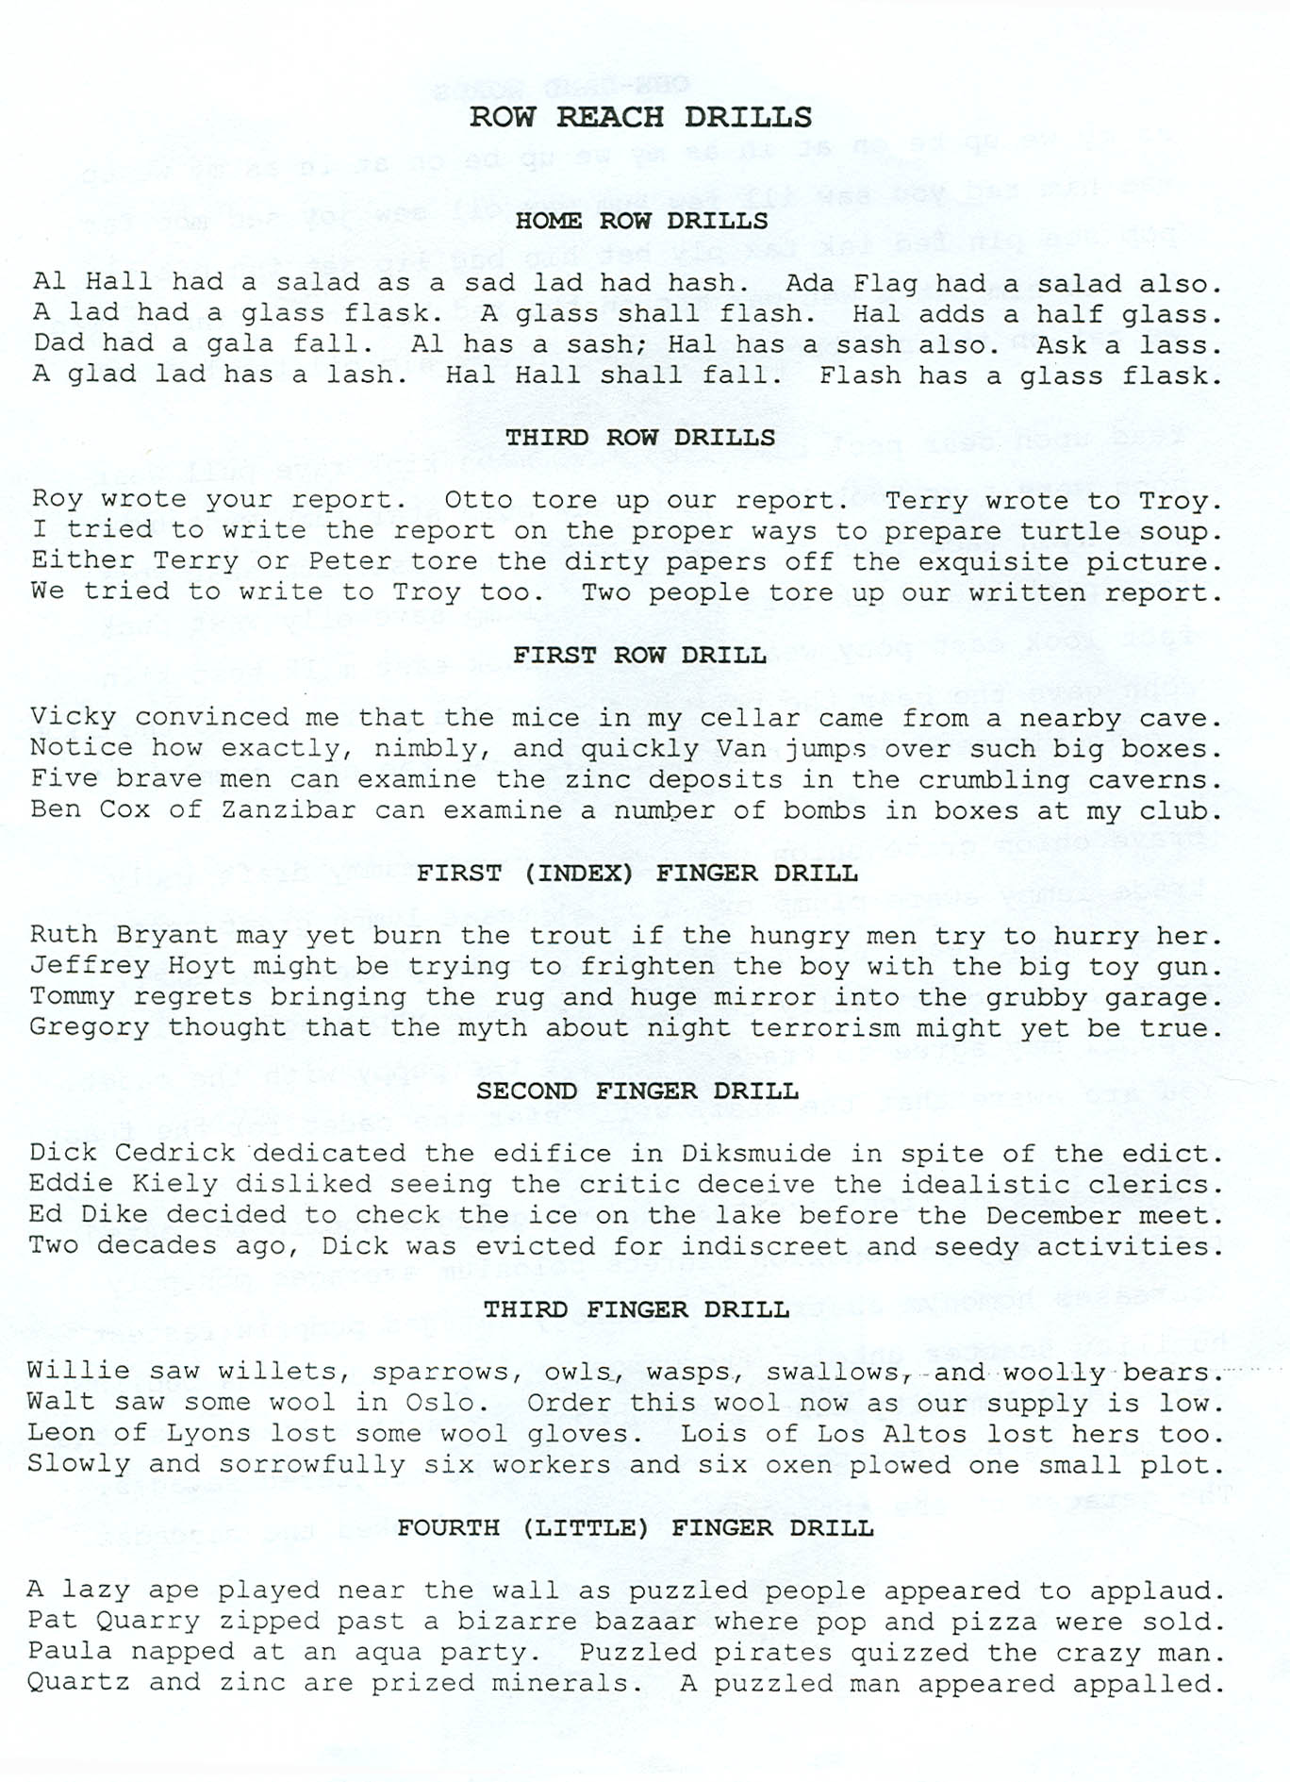
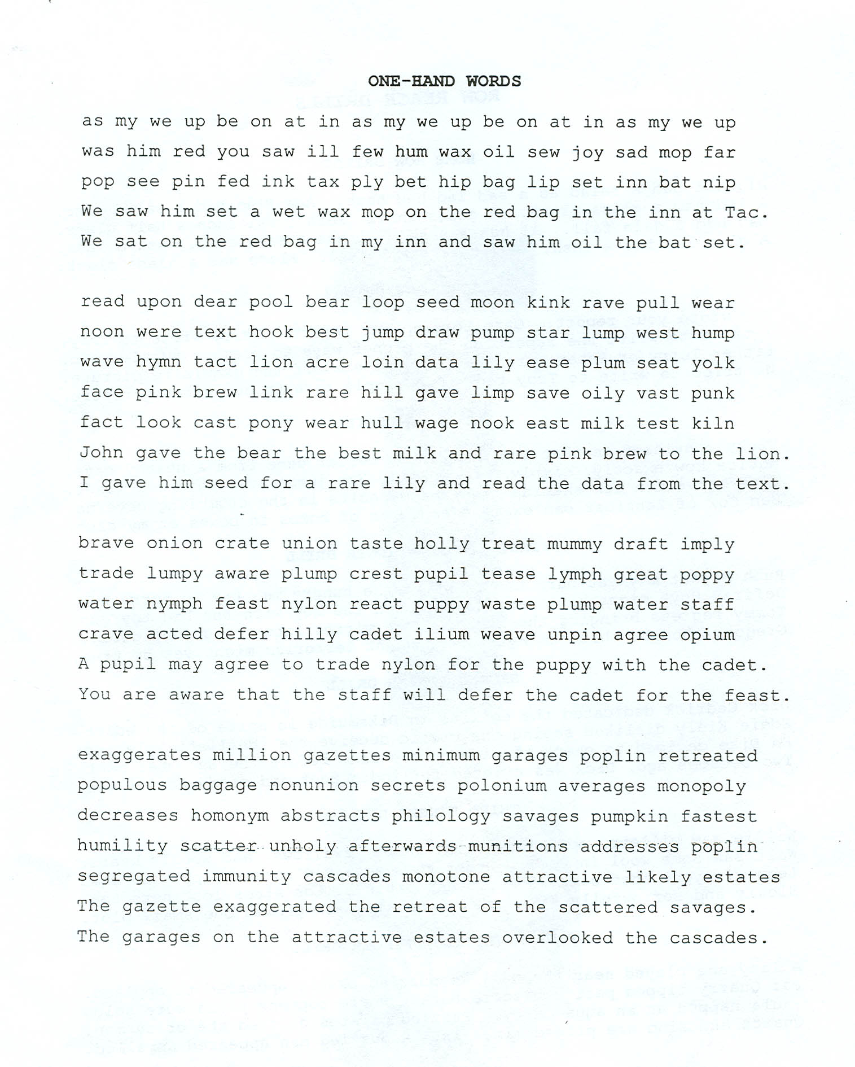
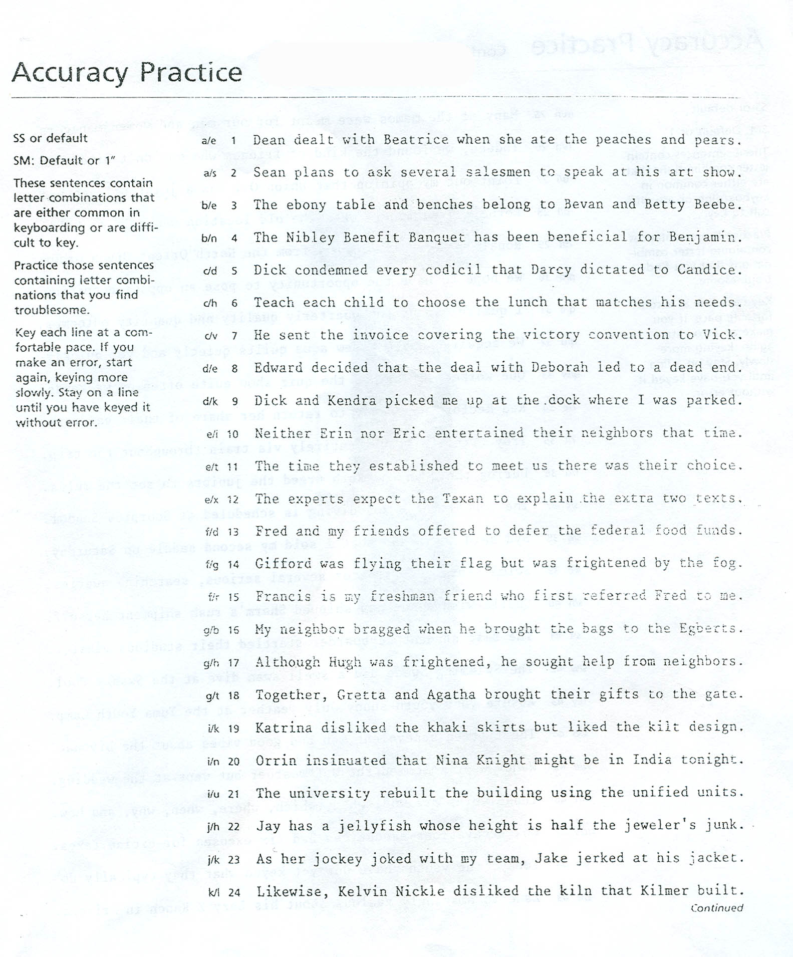
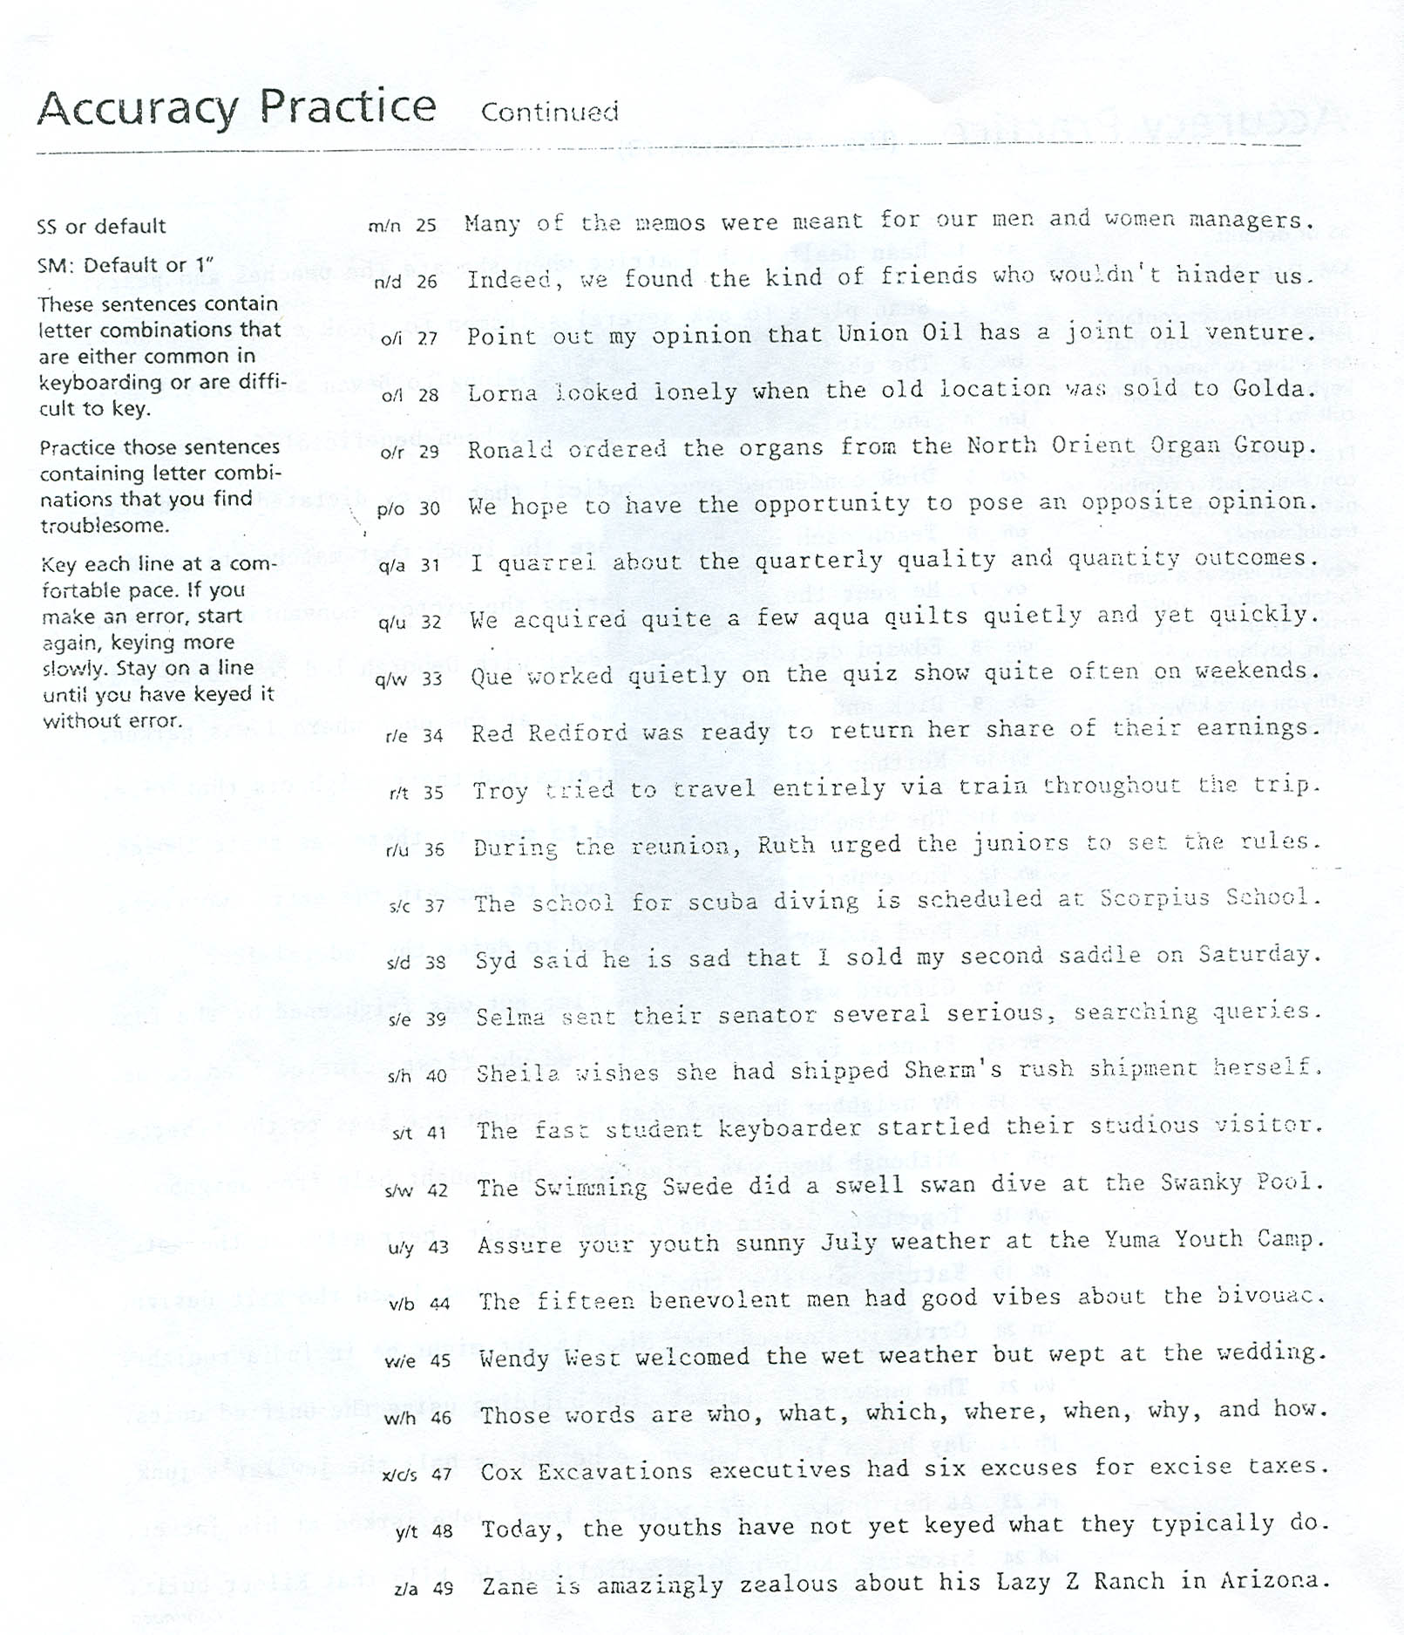
Address Practice

Directions:
- Open Microsoft Office 2007
- Make sure you are set to the 2003 default. On the Home ribbon, go to Change Styles, Style Set. Choose 2003. Then go to Change Styles again and click Set as Default
- Type each address exactly as it appears on the paper.
- Do NOT use your 10-key to type the numbers!

Connie Lynn Meyers
8136 S. 2789 W.
West Jordan, UT 84088

Elmer Whitewood
460 E. 8490 S.
Sandy, UT 84093

Mr. & Mrs. Evan Dericott
64 W. 200 N.
Tremonton, UT 84337

Isadore Brown
167 E. 600 N.
Spring City, UT 84665

Jorge Gonzalez
6333 Owensboro Dr.
West Jordan UT, 84084

John & Laynie Drew
2358 S. 1440 W.
West Valley, UT 84119

Zions First National Bank
1622 W. South Jordan Parkway
South Jordan, UT 84095-8857

Aeropostale
6191 South State Street
Murray, UT 84107

Michael Linzay
1746 Millcreek Cir
East Millcreek, UT 84106

Miss Emma Johnson
474 7th Ave
Salt Lake City, UT 84103

Nestor & Esperenza Lopez
660 E. 1050 N.
Bountiful, UT 84010

Mr. Pierre Perot
278 N. 800 W.
Orem, UT 84057

Mrs. Emiline Dawson
216 W. Center St
Loa, UT 84747

Morrison Wheaton
502 Diagonal St
St George, UT 84770

Mrs. Dawn Henderson
220 Yellow Sky St
Las Vegas, NV 89145

Safari Inn Downtown
1070 Grove St
Boise, ID 83702

Emily Smythe
3960 NE 9th Ave
Portland, OR 97212

Elliot & Denise Schwendiman
2114 N. Fernwood St
Roseville, MN 55113

Tillman Wright
16 Cross Gates Rd
Rochester, NY 14606

Mr. & Mrs. Dallin Golightly
3694 Greenwich Rd
Ware, MA 01082

Mrs. Juana Blinkner
8564 Mathilda Ave
Affton, MO 63123

Debbie Marie Maynes
566 San Pedro Dr
Grand Prairie, TX 75051

Embers Steak House
700 Bourbon Street
New Orleans, LA 70116-3156

Bank of America
801 East Lancaster Avenue
Villanova, PA 19084-1602

Jerrica Romney
8816 W. Francis PI
Lakewood, CO 80215

Geil Elementary School
1600 D Street
Gearig, NE 69341-3900

Ms. Augustina Crowse
420 Royal Glen Ln
Chico, CA 95973

Address Practice Continued

Seth Hathaway
5704 W. Villa Theresa Dr.
Glendale, AZ 85308

Mr. Glen Hansen
734 W. Commercial St
Broken Arrow, OK 74012

Mr. & Mrs. Tom Mackelburg
6 Drew St
Augusta, ME 04330

Flower Hospital
5200 Harroun Road
Sylvania, OH 43560

Resthaven Funeral Home
4400 Bardstown Road
Louisville, KY 40218-3255
Chili’s Grill & Bar
3960 E. 82nd Street
Indianapolis, IN 46240-2467

Raleigh Memorial Park
7501 Glenwood Avenue
Raleigh, NC 27612-1866

LeWanda Tanistry
574 E. Polk Avenue
Lake Wales, FL 33853

Studio By the Tracks
301 20th Street South
Irondale, AL 35210-1637

Atlanta Botanical Garden
1345 Piedmont Avenue Northeast
Atlanta, GA 30309-3366

Shedd Aquarium
1200 S. Lake Shore Dr
Chicago, IL 60605

Joanne Everett
220 W. 18th St Apt #25
Sioux Falls, SD 57105
Jamie Allen
7818 Leawood Blvd
Little Rock, AR 72205

Palace Buffet
94-780 Meheula Parkway
Mililani, HI 96789

Simply Thai Restaurant
37 W. 10600 S.
Sandy, UT 84070

Dr. John Morrow
3491 W. 4800 S.
Roy, UT 84067-9429

Park City Racquet Club
1200 Little Kate Road
Park City, UT 84060

Ms. Patience Wilder
458 golden Pheasant Dr
Draper, UT 84020

Donald Corrigan
276 N. 300 E. St
Spanish Fork, UT 84660

Adobe Theater
9813 4th Street Northwest
Albuquerque, NM 87114-2121

Arthur & Jennifer Wells
280 Columbia Street Apt #B
Milford, DE, 19963

Mrs. Blaire Rhode
570 N. Valley Ave
Vineland, NJ 08360

Hidden City Café
132 E. 24th Street
New York, N Y 10010

Daniel McDowell
34 S. Main St #312
Auburn, ME 04210
Dr. Elaine Grace
1211 Medical Center Drive #101
Nashville, TN 37232

Microsoft Corporation
870 Market Street
San Francisco, CA 94102

Miss Jessica Turner
320 N. 100 W.
Cedar City, UT 84721

Mr. Russell Deyer
32 W. 200 N.
Roosevelt, UT 84066

Riot Zone Family Fun Park
439 N. 4000 E.
Rigby, ID 83442

Fort Buford State Historic Site
15349 39th Lane NW
Williston, ND 58801

Sunset Lanes
261 East E Street
Forks, WA 98331*9043

Yellowstone Grizzly RV Park
210 S. Electric Street
West Yellowstone, MT 59758

Pioneer Park Dance Center
2300 Airport way
Fairbanks, AK 99701-4014

Megan Lewiston
701 S. Franklin Street
Denver, CO 80209-4504

Alex Carson
1382 Willow Street South
Minneapolis, MN 55403-2256

Chickasaw National Recreation 1008 W. 2nd Street
Sulpher, OK 73086-4814

Directions:
- Before beginning, add a header with your name (insert>header). Close header when finished.
- Next type your title – Random Dates in History – and change the font to the font of your choice. Change the font size to 30. Press enter twice.
  - Click the clear button to clear your formatting.
- Finally, create your own custom bullets. On your Home ribbon, click on the arrow next to the bullet button. Choose Define New Bullet from the menu. Then click the “picture” button and do a clipart search for an image related to one of the bullet points you will be typing up.
- Type each date in its entirety, exactly as written. When you finish entering one entry, pressing enter will cause another bullet to appear.

Random Dates in History

- May 1, 1486 - Christopher Columbus convinced Queen Isabella to fund an expedition to the West Indies.
- October 15, 1951 – “I Love Lucy” premiered on CBS-TV
- March 14, 1794 – Eli Whitney received a patent for his cotton gin.
- October 17, 1989 – An earthquake measuring 7.1 on the Richter Scale hit the San Francisco Bay area in California. The quake caused about 67 deaths, 3,000 injuries, and damages up to $7 billion.
- November 29, 2004 – Godzilla received a star on the Hollywood Walk of Fame
- August 12, 1939 – “The Wizard of Oz” premiered on Oconomowoc, WI. Judy Garland became famous for the movie’s song, “Somewhere Over the Rainbow.” The movie premiered in Hollywood on August 15th.
- September 10, 1608 – John Smith was elected president of the Jamestown, VA colony council.
- February 1, 1987 – Terry Williams won the largest slot machine payout, at the time, when they won $4.9 million after getting four lucky 7’s on a machine in Reno, NV.
- December 26, 1620 – The Pilgrim Fathers landed at New Plymouth, MA, to found Plymouth Colony, with John Carver as Governor.
- July 21, 2007 – The seventh and last book of the Harry Potter series, “Harry Potter and the Deathly Hallows,” was released.
- May 9, 1951 – Jim Gentile (Baltimore Orioles) set a major league baseball record when he hit a grand slam home run in two consecutive innings. The game was against the Minnesota Twins.
- April 18, 1980 – Rhodesia became the independent nation of Zimbabwe.
- May 26, 1647 – A new law banned Catholic priests from the colony of Massachusetts. The penalty was banishment or death for a second offense.
- February 7, 1795 – The 11th Amendment to the U.S. Constitution was ratified.
- August 17, 1859 - A hot air balloon was used to carry mail for the first time. John Wise left Lafayette, IN, for New York City with 100 letters. He had to land after only 27 miles.
- September 24, 1957 - U.S. President Eisenhower sent federal troops to Little Rock, AR, to enforce school integration.
- October 1, 1903 – The Model T automobile was introduced by Henry Ford. The purchase price of the car was $850.
- January 14, 1986 - "Rambo: First Blood, Part II" arrived at video stores. It broke the record set by "Ghostbusters", for first day orders. 435,000 copies of the video were sold.
- March 6, 1836 - The thirteen-day siege of the Alamo by Santa Anna and his army ended. The Mexican army of three thousand men defeated the 189 Texas volunteers.
- April 13, 1860 - The first mail was delivered via Pony Express when a westbound rider arrived in Sacramento, CA from St. Joseph, MO.
- November 8, 2000 - In Florida, a statewide recount began to decide the winner of the 2000 U.S. presidential election.
- June 22, 1772 – Slavery was outlawed in England
- December 13, 1884 - Percy Everitt received a patent for the first coin-operated weighing machine.
- January 4, 1896 – Utah became the 45th state
- April 27, 1982 - The trial of John W. Hinckley Jr. began in Washington. Hinckley was later acquitted by reason of insanity for the shooting of U.S. President Reagan and three others.
- July 31, 1928 - MGM’s Leo the lion roared for the first time. He introduced MGM’s first talking picture, "White Shadows on the South Seas."
- November 23, 2001 - A crowd of 87,555 people watched the Texas Longhorns beat the Texas A&M Aggies 21-7. The crowd was the largest to see a football game in Texas.
- March 19, 2003 - U.S. President George W. Bush announced that U.S. forces had launched a strike against "targets of military opportunity" in Iraq. The attack, using cruise missiles and precision-guided bombs, were aimed at Iraqi leaders thought to be near Baghdad.
- March 5, 1624 - In the American colony of Virginia, the upper class was exempted from whipping by legislation.
- November 16, 1957 - Jim Brown (Cleveland Browns) set an NFL season rushing record of 1163 yards after only eight games.
- October 10, 1995 - Gary Kasparov won a chess championship against Viswanathan Anand that had lasted about a month.
- January 15, 1987 - Paramount Home Video reported that it would place a commercial at the front of one of its video releases for the first time. It was a 30-second Diet Pepsi ad at the beginning of "Top Gun."
- February 16, 1862 - During the U.S. Civil War, about 14,000 Confederate soldiers surrendered to Gen. Ulysses S. Grant at Fort Donelson, TN.
- November 2, 1984 - Velma Barfield became the first woman to be executed in the U.S. since 1962. She had been convicted of the poisoning death of her boyfriend.
- August 15, 1877 - Thomas Edison wrote to the president of the Telegraph Company in Pittsburgh, PA. The letter stated that the word, “hello” would be a more appropriate greeting than “ahoy” when answering the telephone.
- September 2, 1666 - The Great Fire of London broke out. The fire burned for three days destroying 10,000 buildings including St. Paul’s Cathedral. Only 6 people were killed.
- April 1, 1960 - The U.S. launched TIROS-1. It was the first weather satellite
- October 25, 1955 - The microwave oven, for home use, was introduced by The Tappan Company

Most Frequently Used Words
First 100
Type 3x

Type 3x in one line—do not press enter until you come to the end of each set of 10.

the  of  to  and  in  you  a  for  we  your | from  us  an  has  all  was  can  any  been  time | some  service  am  business  now  their  also  know  me  enclosed | like  had  such  his  work  most  use  program  appreciate  years
that  is  be  this  will  on  have  our  are  I | one  these  letter  may  please  do  new  order  but  they | about  up  company  were  them  who  out  make  when  he
with  as  it  at  by  or  not  if  which  would | so  there  very  other  should  no  information  year  office  more | than  made  each  only  my  thank  two  copy  department  many

Most Frequently Used Words
Second 100
Type 3x

Type 3x in one line—do not press enter until you come to the end of each set of 10.

send  good  much  under  what  hope  first  state  get  just | after  give  through  policy  price  best  see  want  during  need | days  next  three  necessary  present  shall  feel  let  here  future | percent  special  upon  interested  then  account  line  mail  material  due
find  help  its  possible  interest  insurance  date  well  over  sales | before  meeting  take  further  received  how  above  being  plan  check | forward  course  report  city  people  sure  those  part  complete  request
number  since  cost  could  however  available  return  school  amount  per | every  area  because  day  must  into  way  form  same  last | month  used  wish  matter  again  additional  call  opportunity  today  might

Most Frequently Used Words
Third 100
Type 3x in one line—do not press enter until you come to the end of each set of 10.

home  paid  credit  following  both  able  pay  where  members  copies | attached  board  enclosing  hospital  regarding  money  pleased  given  card  receive | recent  system  back  prices  rate  set  building  items  federal  customers | several  supply  less  charge  national  products  contract  happy  therefore  association
full  general  him  free  note  believe  list  committee  payment  equipment | life  attention  total  period  tax  months  advise  job  making  bill | while  type  basis  employees  important  book  long  personal  property  invoice
few  without  application  sent  soon  stock  until  own  public  high | come  past  write  concerning  within  look  position  case  week  offer | provide  name  think  having  better  reply  receipt  great  loan  increase

Most Frequently Used Words
Fourth 100
Type 3x in one line—do not press enter until you come to the end of each set of 10.

questions  change  too  contact  division  done  value  keep  member  assistance | does  bank  another  water  certainly  education  glad  go  problem  reference | addition  required  states  annual  continue  problems  college  current  five  visit | customer  probably  manager  staff  rates  cannot  kind  approximately  power  shown
even  going  group  requirements  did  four  government  companies  county  management | effective  plans  letters  needs  operation  show  between  income  president  ask | record  small  claim  ever  size  cooperation  organization  field  serve  representative
students  held  right  services  purchase  shipment  still  local  requested  records | market  place  statement  thanks  why  fact  issue  delivery  production  whether | section  regards  various  membership  recently  don’t  experience  men  savings  sending

Most Frequently Used Words
Fifth 100
Type 3x in one line—do not press enter until you come to the end of each set of 10.

suggest  meet  reason  working  dealers  room  training  either  large  subject | pleasure  cash  dated  orders  family  project  already  covering  direct  premium | fine  balance  said  ago  always  law  looking  old  taken  never | effort  hand  quality  ten  issued  sheet  become  dealer  individual  support
costs  immediately  low  notice  care  convenience  study  weeks  regular  administrating | protection  schedule  inquiry  original  question  real  completed  fill  forms  industry | once  trust  world  box  development  community  defense  file  returned  appreciated
control  little  put  cover  district  hear  along  benefits  desire  page | store  books  end  sale  point  writing  advertising  consideration  planning  agency | construction  machine  second  address  merchandise  read  oil  asked  unit  down

Most Frequently Used Words
Sixth 100
Type 3x in one line—do not press enter until you come to the end of each set of 10.

say  answer  act  action  benefit  shipped  six  wishes  doctor  envelope | attend  labor  bring  personnel  convention  investment  certain  employment  prior  student | operations  provided  rather  paper  particular  entire  expect  far  means  she | together  short  director  discuss  immediate  monthly  policies  agreement  materials  post
found  her  item  plant  purpose  times  proposed  receiving  telephone  tell | furnish  sincerely  situation  against  commission  executive  others  reports  street  air | trade  model  sample  unable  areas  bonds  cents  helpful  listed  sold
written  cases  class  off  approval  doing  include  loss  perhaps  understand | enough  half  needed  open  yet  increased  facilities  product  changes  connection | thought  average  funds  sell  you’ll  result  below  including  indicated  reserve
Most Frequently Used Words
Seventh 100
Type 3x in one line—do not press enter until you come to the end of each set of 10.

unless  effect  least  programs  promptly  run  expense  man  person  success | regulations  research  results  sign  hesitate  something  certificate  prompt  summer  advised | correct  extra  giving  opinion  successful  date  excellent  interesting  space  try | car  catalog  review  signed  taking  throughout  units  estate  event  fall
understanding  buy  country  handling  major  quite  showing  things  yourself  health | assure  examination  freight  hearing  net  north  proper  standard  although  coverage | discount  follows  herewith  mind  plus  united  financial  firm  addressed  called
included  remain  according  agent  consider  fee  house  outstanding  persons  prepared | lot  suggestion  teachers  big  delay  electric  ship  using  accept  approved | corporation  land  lines  mailing  method  operating  schools  terms  advance  anything

Most Frequently Used Words
Eighth 100
Type 3x in one line—do not press enter until you come to the end of each set of 10.

idea  million  regret  coming  council  details  final  gas  getting  morning | express  greatly  newes  postage  ready  sorry  accounts  beginning  bureau  designed | taxes  enclose  farm  remember  top  war  arrangements  machines  methods  save | center  different  especially  medical  parts  process  satisfactory  welcome  bulletin  deposit
payments  placed  among  considered  continued  directly  easy  head  limited  regard | obtain  proposal  provides  truck  booklet  condition  dollars  established  picture  specific | suggested activities  appreciation  early  expenses  hold  offices  practice  south  submitted
force  hours  involved  late  near  require  selling  station  assist  except | accounting  gives  ideas  it’s  later  mailed  minimum  obligation  security  similar | view  advantage  conditions  friend  brochure  charges  clear  discussed  fire  mentioned

Most Frequently Used Words
Ninth 100
Type 3x in one line—do not press enter until you come to the end of each set of 10.

fair  files  growth  industrial  profit  returning  seems  start  agree  conference | fully  particularly  progress  separate  accordance  asking  close  determine  facts  furnished | personally  purposes  season  self  teaching  carbon  children  claims comments  friends | active  agents  extended  filing  maintenance  shipping  test  third  trip  campaign
correspondence  handle  inch  indicate  stell  sup[lies  volume  acknowledge  apply  around | kindly  retail  basic  concerned  features  greater  invitation  respect  series  serving | offered  permit  private  procedure  provisions  samples  article  commercial  food  level
carry  chairman  factory  feet  spring  title  added  based  court  distribution | bills  cards  developed  foreign  housing  instructions  known  left  manner  organizations | share  checks  convenient  deal  demand  dozen  makes  manual  miss  seeing

Most Frequently Used Words
Tenth 100
Type 3x in one line—do not press enter until you come to the end of each set of 10.

classes  follow  higher  quantity  range  secretary  valuable  yours  capital  everything | mortgage  officers  payable  printed  professional  thus  transportation  actual  add  behalf | maximum  portion  purchased  radio  responsibility  source  thing  civil  economic  efforts | ordered  otherwise  toward  university  adequate  boys  simply  speed  ability  brought
example  age  central  cut  decision  faculty  longer  side  weekly  west | insured  legal  referred  touch  appear  assured  bond  fund  hotel  located | employee  engineering  goods  grade  manufacturing  meetings  points  revenue  sheets  television
away  banks  code  color  congress  considerable  conversation  covered  forwarded  lease | press  previous  stores  told  town  accident  arrange  branch  completely  daily | travel  trouble  actually  ahead  appropriate  base  earliest  kindest  marketing  mutual
Most Frequently Used Words
Eleventh 100
Type 3x in one line—do not press enter until you come to the end of each set of 10.

damage  develop  difficult  educational  evening  i’m  increased  informed  offering  performance | literature  presented  relative  reported  requesting  road  sincere  term  twenty  aid | officer  story  sufficient  survey  wrote  appears  authorized  blank  budget  directors | improvement  lower  red  tire  useful  appointment  authority  begin  contracts  foot
release  risk  substantial  teacher  almost  checking  design  indeed  phone  safety | applications  aware  carefully  chance  chapter  fast  includes  knowledge  larger  main | doubt  endorsement  exchange  fiscal  hard  inform  international  participation  procedures  promotion
served  stated  whatever  words  analysis  build  church  entitled  instead  license | quickly  refer  shows  subscription  types  club  courses  extend  motor  nothing | published  recommend  replacement  salary  single  thanking  whom  applied  charged  dollar

Most Frequently Used Words
Twefth 100
Type 3x in one line—do not press enter until you come to the end of each set of 10.

liability  manufacturers  nature  qualified  realize  requests  submit  thousands  turn  calls | storage  western  amendment  buying  contribution  enable  face  learn  matters  names | fees  figures  green  highly  potential  providing  reasons  secure  that’s  thirty | route  secretarial  session  shares  simple  technical  yes  young  agencies  come
desk  drive  drop  filed  floor  generally  groups  hour  join  manufacture | night  presently  publication  reach  response  shipments  southern  talk  traffic  word | treasury  wanted  accepted  accordingly  cause  enjoy  excess  explain  felt  figure
numbers  papers  paying  possibly  pounds  reading  representatives  seem  selected  step | worth  allow  associations  automobile  certified  citizens  confidence  described  double  earnings | finance  handled  heard  latest  move  pages  prove  really  reasonable  relations

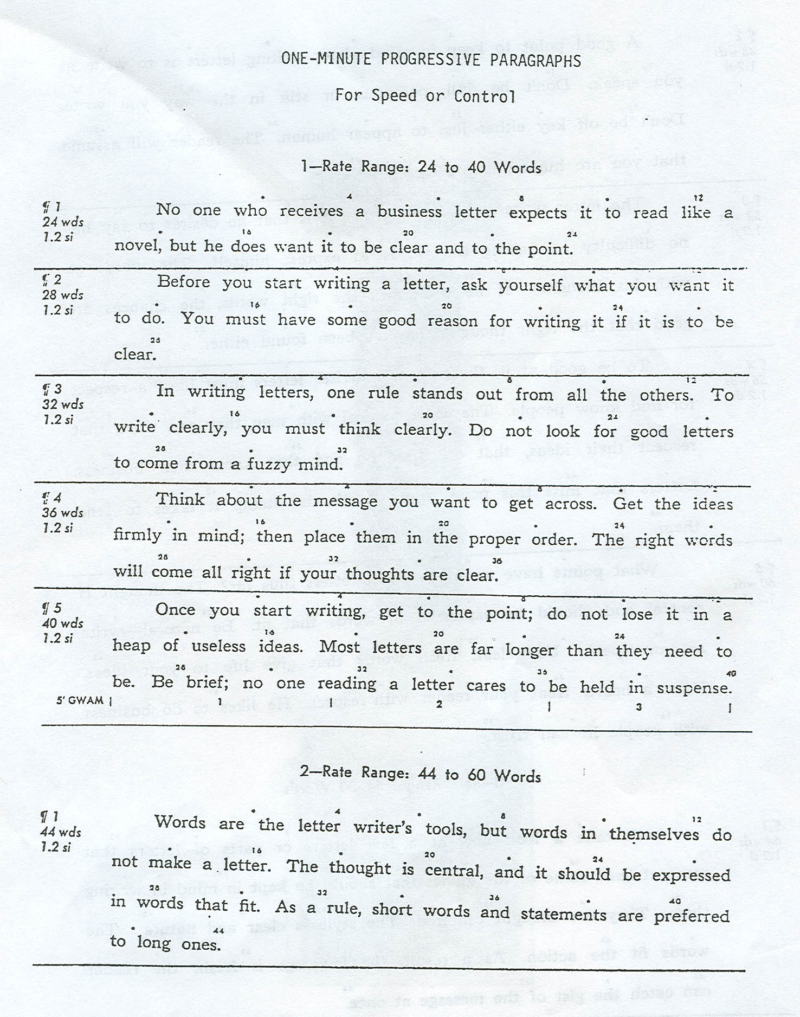
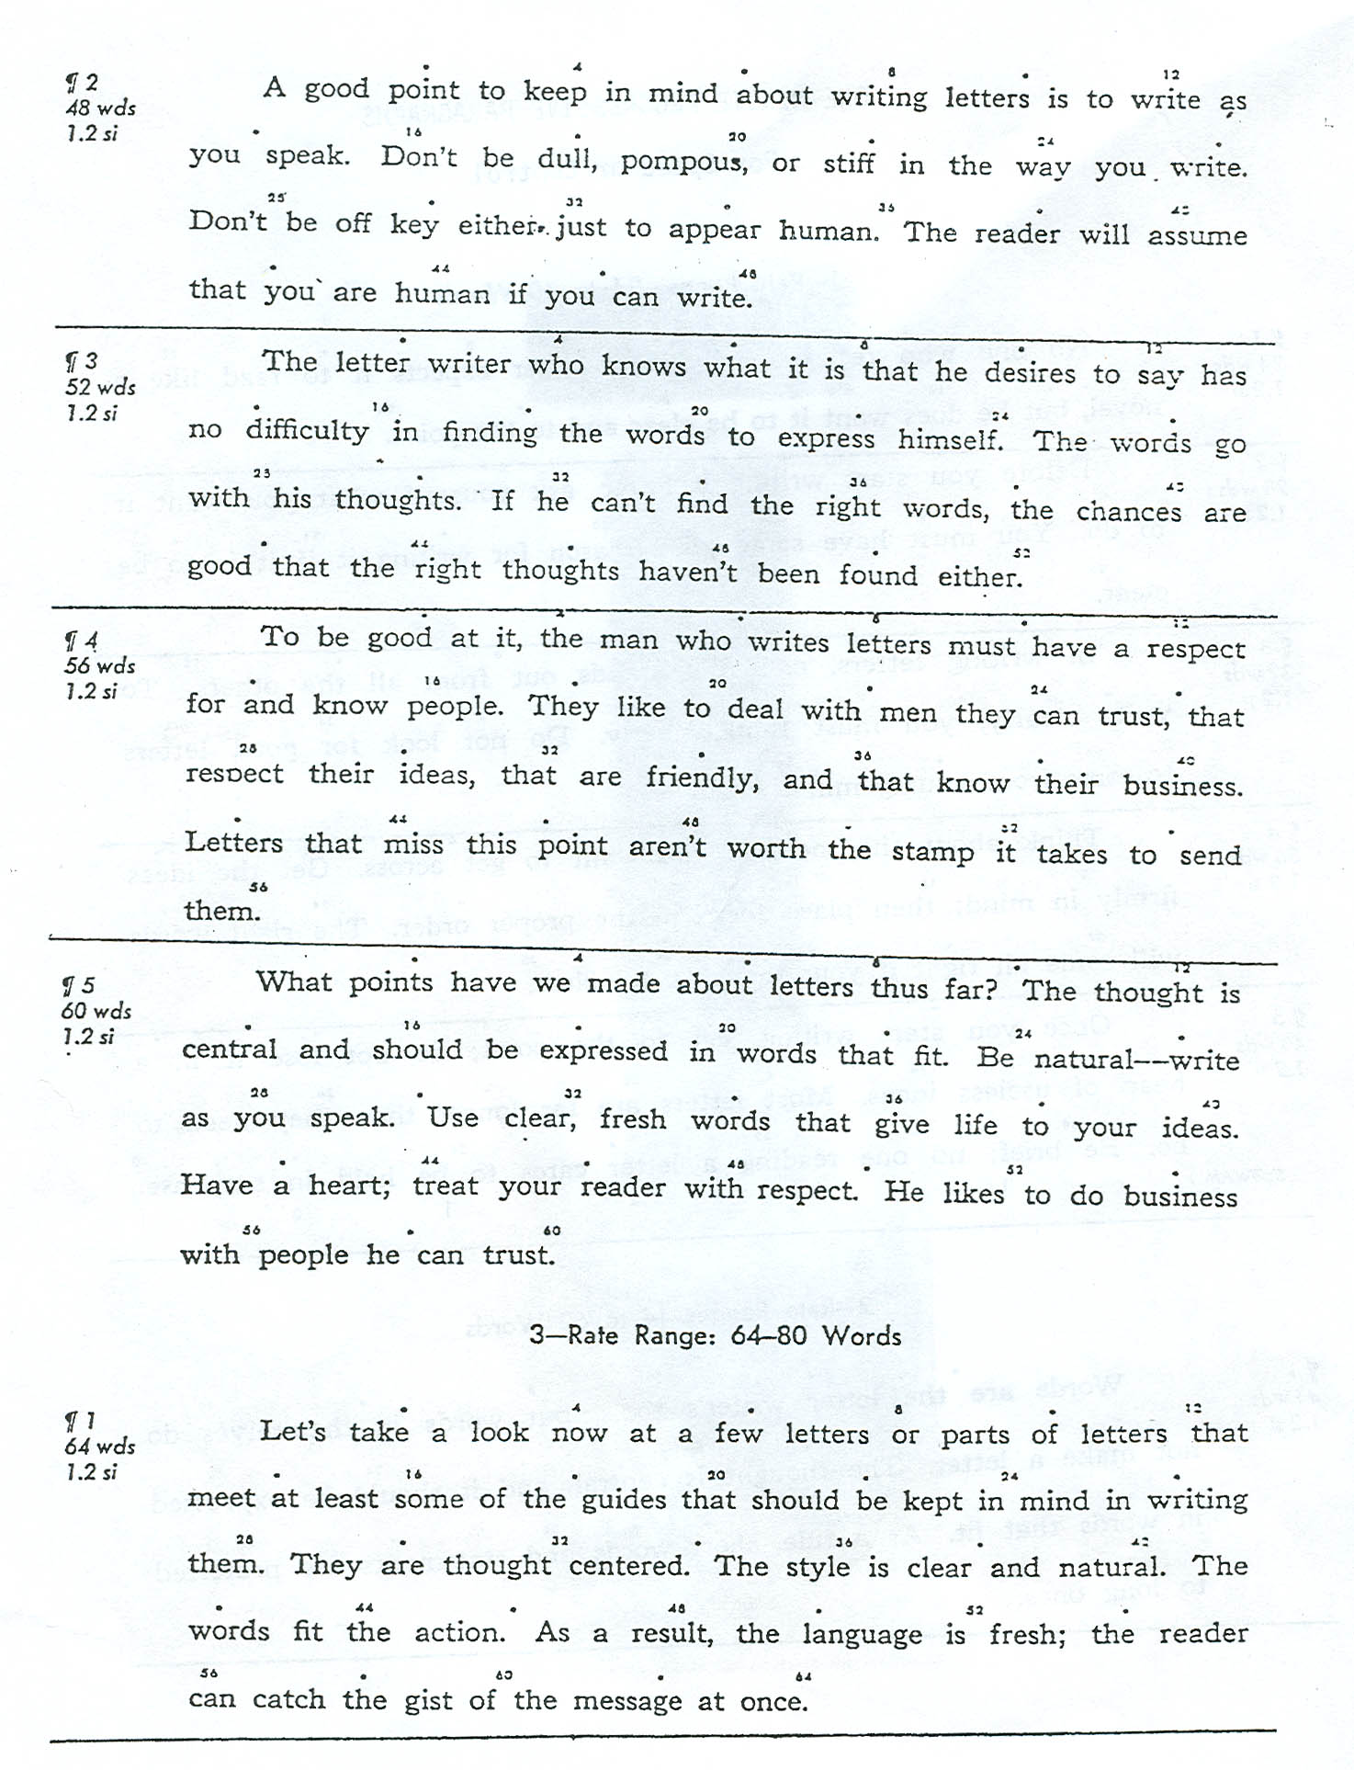
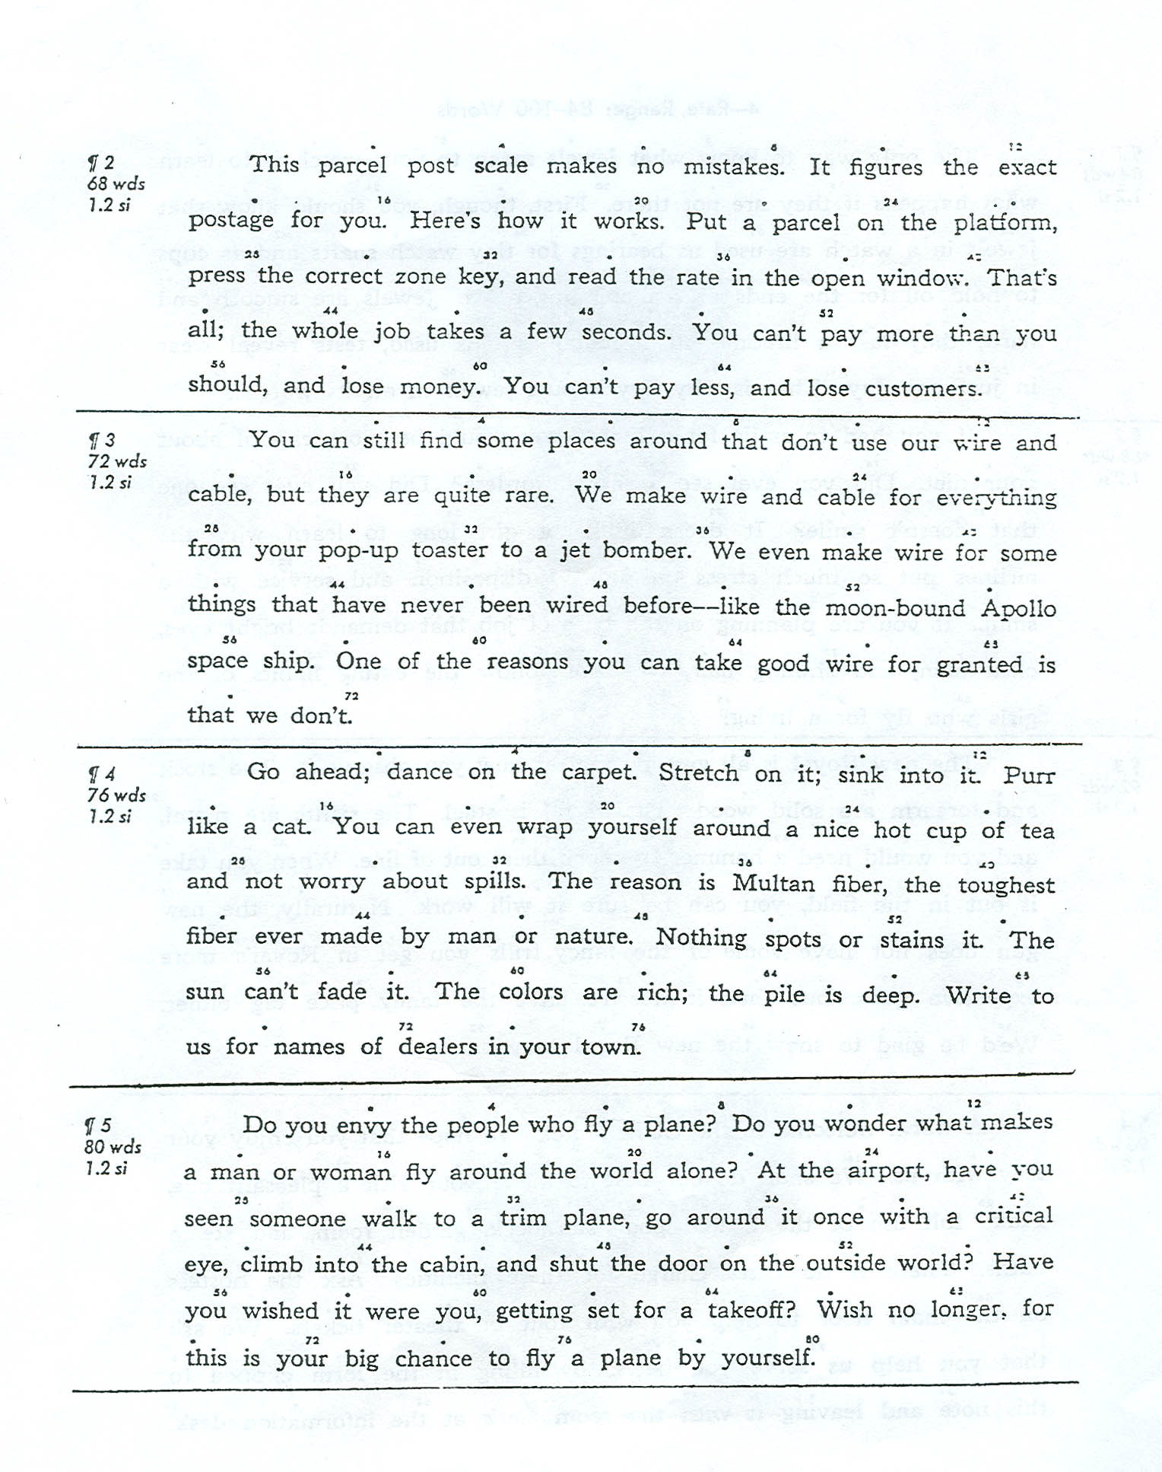
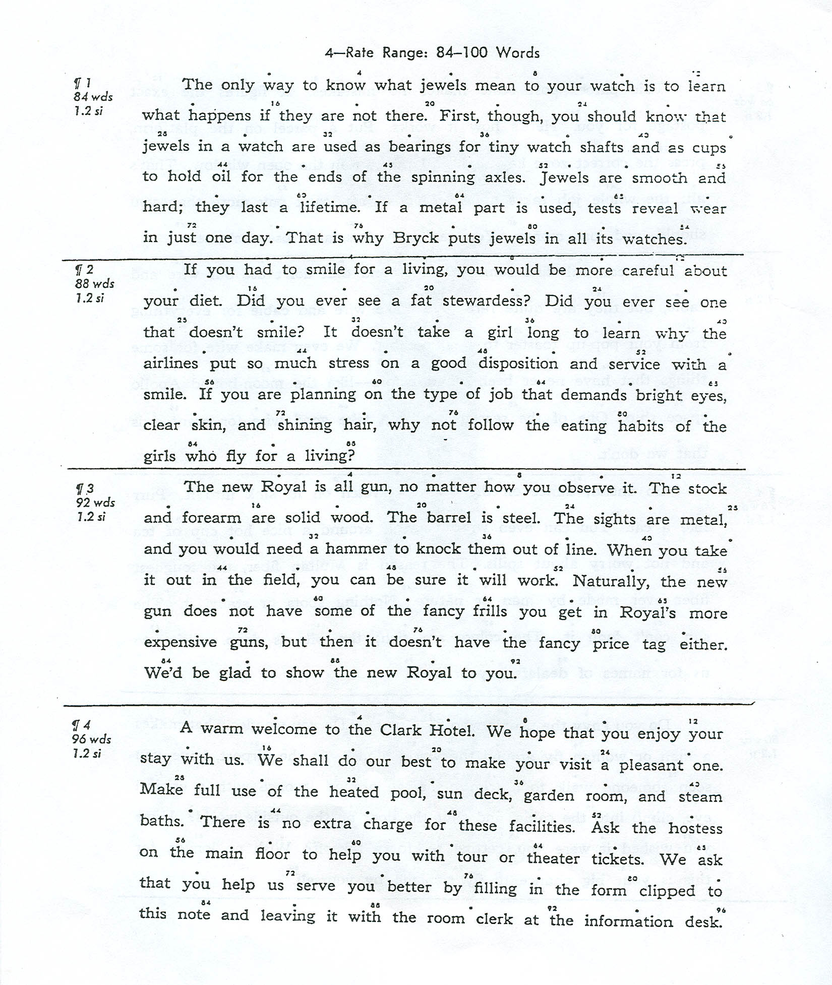

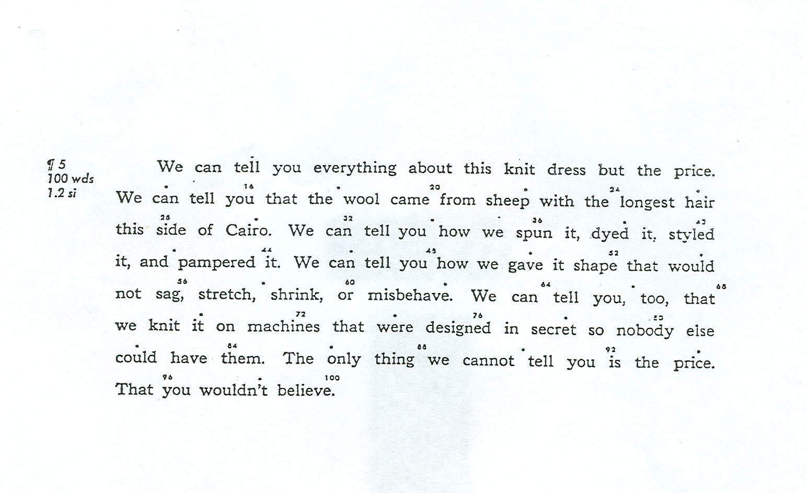

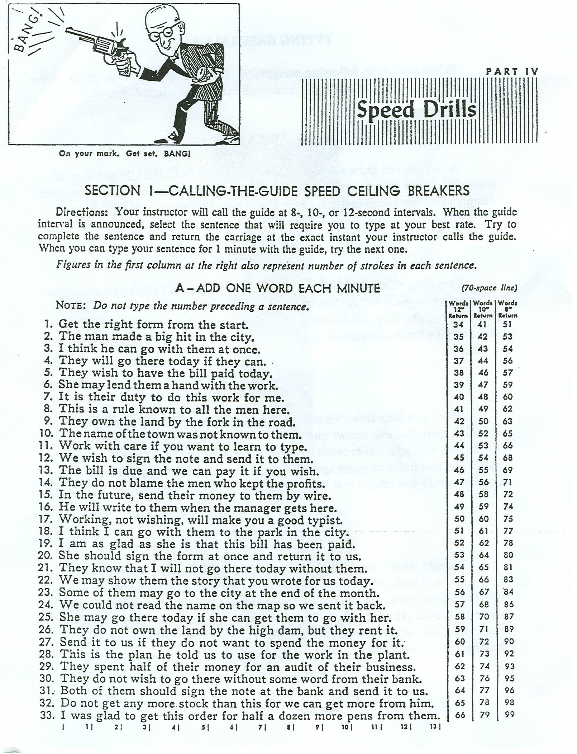
Drill 1
Abate aware accede agree axle award acquaint afterward awful arguable

Available askance arbitrate azalea attracted abandon acrobatics awash

Believe between before bargain breeze become back barter brazen brave

Bright beatable baggage brass brick bludgeoning bathtub barbecue brat

Car cease creased crazed catacombs cactus caucuses capsized criticize

Cosmopolitan critic civics catastrophe cube chewable cortege caulking

Drill 2
Deeded decedents doubtful detected defenses deferred day dash dredged

Devastated degreasers determination debatable delays drafted decipher

Eerie except economy edged evolution evaded equanimity eraser evicted

Effected extravaganza exaggerate every equip echelon eatable extracts

Frazzle facsimile frequent fraught fleeced fewer farewell frugal fact

Fancy feared fretful fantastic frolic façade federate fragrances free

Drill 3
Grudgingly gauging gingerly goggles giggling greatest granite gratify

Gregarious generous grateful garage grand gigantic grandiose grabbing

Highlight hardy hungry humble humiliate hither height heartthrob hunt

Haughty hurtful hosiery headhunter harass hurried hillside heartbreak

Invincibility initiative inquisition inimitable individuality ionized

Iniquity illness invite indefatigable invade implore imply immunology

Drill 4

1-Minute timing

Type in open screen of Micro Type pro—set your timer for 1 minute.

What is it that makes one person succeed and another fail when the two seem to have about equal ability? Some have said that the difference is in the degree of motivation and effort each brings to the job. Others have said that an intent to become excellent is the main difference.
At least four items are likely to have a major effect on our success: basic ability, a desire to excel, an aim to succeed, and zestful effort. If any one of these is absent or at a low point, our chances for success are lessened. These features, however, can be developed if we wish.
Drill 5

Junior jumping juxtaposed jiggle jigsaw jiffy jingle jitterbug jolted

Job joblessness jockey jocularity jog joggle join jointly journalized

Kangaroo knight khaki kimono kibitzer kicking kidney kilts kidnapping

Kilocycle kilogram kilometer kin kilowatt kilovolt knitting kilter

Limitless liability lightly leveling lavaliere lovelier loyalty likes

Libel life lively lifts lifeless ligament luggage lunar lye limitless

Drill 6
Management minutemen magnanimity minute money manly mammoth

Minimized maximum murmur mumps milk million manikins minimums

Nineteen nuance nihilism nominal nominations nozzle numerator

None nun nullify nylon nonofficial nuclear nonprinting no nonsense

Oh oily only odorless oleomargarine onions odd Olympiad orchestra

Ombudsman ominous opportunity opponent opposite on omnipresent
Drill 7

Portray pinpoint pretzels portfolio pizzazz precedence police policy

People population physician physicist physiology polo pole puny puppy

Quotient quote quotas quorum quotation quizzical quiver quite quintet

Quixotic quitclaim quits quirks quisling quips quintuples queried

Rebel rave razed revere retreat reward requests razzed react rhubarbs

Reverberated receded rested racquetball rutabagas reassessed ragweed

Drill 8

1-Minute timing

Type in open screen of Micro Type pro—set your timer for 1 minute.

Planning is the first step in composing a message. The plan should include a goal, what you want to accomplish. It also should include a list of the points you will use to convince the reader of your point of view or of the action you want taken. The list should be arranged in logical sequence.
Your goal is the major idea behind the topic sentence. The topic sentence is often stated first, followed next by facts and ideas that support it. You may instead decide to work up to the main idea at the end. In either case, you itemize the information and tie it to the main thought.
Drill 9

Sewers severe seven sextet seesaw seaweed scarcity statistics swerved

Seafarer statecraft started sweet sweat squarely staggered segregated

Targeted tweezers tripartite treat threatened tooth twisters trapezes

Technology triumph tutoring taffeta tattered teeters torture truthful

Unjust unnumbered unfair unbundled unblocked unhurried understand

Unusually untruthful untutored unimpeded ungracious unpopular

Drill 10

Vivid vicarious vacates vascular vanquish velvet variables verve vary

Vases vaults varsity varnish veered veal vellum vegetate vicious vita

Watercress westward wintergreen waterish welfare warfare wrong

Wetter wettest weave watercrafts weedier weeded waxed waste water

Xanthate xanthene xanthin xerophthalmia xenophobia xanthomata

Xanthoma xanthophylls xanthophyllic xanthophyllous xenolithic

Drill 11
Youth youthful yesterday yesteryear yield yielding yodel yogurt yokel

Yoga yardage yolks yonder your yourself yourselves young younger

Zany zanies zealotry zeal zealot zealously zebra zebu zenith zenithal

Zones zonal zephyrs zero zincky zest zirconium zodiac zip zigzag zipper

Pin pink pull plush piano pool pulpit pumpkin pupil piping pilfer pop

Plod plot plotting plum plumb plunk plump pump poison poke point

Drill 12

1-Minute timing

Type in open screen of Micro Type pro—set your timer for 1 minute.

As you work for higher skill, remember that how well you key fast is just as important as how fast you key. How well you key at any speed depends in major ways upon the technique or form you use. Bouncing hands and flying fingers lower the speed, while quiet hands and low finger reaches increase speed.
Few of us ever reach what the experts believe is perfect technique, but all of us should try to approach it. We must realize that good form is the secret to higher speed with fewer errors. We can then focus our practice on the improvement of the features of good form that will bring success.
Drill 13

Barb badgered bartered battered beverages bags bread breezes bereft

Beebread berated bereaved breakfast beguiling bazaar bequest bathrobe

Fewer fever freeze faze fracas facet forefront fearful folklore feels

Fables fortress frenzy friends forthrightness frightfully firefighter

Greedy garage garb garbage grade grave grace grasshopper graze gadget

Gratuity grateful gaze gavel greetings gyrate geese greaser graduates

Drill 14

Honolulu hulk hump holly haulm hoop holy hill hilly hull hymn hip him

Hybrid hygiene helicopter honor homogenous haphazardly helium

Journey journalism jubilee jubilant judge judgments jubilation jostle

Joke joist jolly jocular judicative juicy juggler julep jumpy jumpers

Tyrant thrifty thrust thirstily thorough thoughtful though taught tipsy

Tightrope turntable throughout thoroughfare traversed traced twisters

Drill 15

Cabaret cabbage crab carafe carefree carfare cassettes cataract cater

Crabgrass craft created cede circle circumvent civil cascade cyclical

Mimeograph mine millennium minimum minuet mismatch mollify mull

Momentum moment monodrama monomolecular murmurs mummified

Uniquely unupholstered unfortunate unqueuing unrealistic unpinpointed

Unusual unaffected unjudged unjudicial undertrained unjaded unluckily

Drill 16

1-Minute timing

Type in open screen of Micro Type pro—set your timer for 1 minute.

In excess of a hundred different makes and models of personal computers are now on the market. An amazing number of software packages are available to use in them. Each software package has its own commands to make an operating system work. Commands that are given in one package often do not work for another program.
An operation guide usually is prepared for each disk package. The guide shows you how to power up and power down the system, how to format a disk, how to copy a disk if permissible, and how to perform various other major functions of which the program is capable. It is necessary to learn the commands required to make your program function.
Drill 17
Detergents drawer drew draw dwarfs dwarfed drifted desecrated dazzled

Defeated desegregated deser4ted defected deadbeats described decreases

Vigil victim viaduct vibrates video views vignette veered vanquished

Vivacious vivacity viand voices vociferous vocation vocabulary volts

Yell yellow yea year yearling yeast yeoman yule yuletide yucca yachts

Yachting yak yam yank yap yard yawl yaws yin yipping yesteryear

Drill 18
Eastward exacerbated exact effervesces estates etcetera excavated ewe

Exceeded excreted exerted extraordinary evergreen egregious exercises

Inn invalid inside insidious intelligibility insensitivity individual

Insatiability instability intangibility indefensibility insignificant

Notifications nonprotein nonproven ninety numerous null noon numerals

Nonsense nurses nosiness notarizations numinous numeration numbs

Drill 19

Anxiety anxious reflex reflexes box boxed awe awed exile axis extreme

Except exceptional extra extreme exact exactness exceed exceeding lax

Keys kind king kingcraft kinetic kingdom kinship kisses kitchen knees

Knack knuckle kitten knock knead knavery knell knew knife knotty

Reserves rearrested retracted retraced refreeze retread retargeting

Resegregate reward reverses restated reimbursed reread retargeting

Drill 20

1-Minute timing

Type in open screen of Micro Type pro—set your timer for 1 minute.

As you build your keying power, the number of errors you make is not very important because most of the errors are accidental and incidental. Realize, however, that documents are expected to be without flaw. A letter, report, or table that contains flaws is not usable until it is corrected. So find and correct all of your errors.
The best time to detect and correct your errors is while the copy remains in the machine or on a monitor. Therefore, just before you remove the copy from the machine or screen, proofread it and correct any errors you have made. Learn to proofread carefully and to correct your errors quickly. This is the way to improve your productivity.

Drill 21

Attested actress attracted average averted abated aggregate arrested

Aggravated awed arcade abstractor aftertaste asseted acreage abscess

Steadfast stargazer stewardess swelteringly sweetbread savages sacred

Salvage serrated subtracted spectrum shortfall shortbread subversions

Watchword whimsical walk waterfront wristwatches wardrobes walking

Wacky wardress waltz wart waxed wayward wear web wedged waterfall

Drill 22

Lilly limps lip lumpy lonely lovely loathed looking liking limelight

Lurch lobster local luxuriate logistics lullaby locker lust locations

Omnivorous overgrown ongoing opposable onerous oblong opposed

Onion opinion opportunistic option oratory ounce overbrewed operators

Quagmire quaint quick qualified query quench quests quinces quintuple

Quilting quill qualification quietude quarrelsome quiescence quivered

Drill 23

1-Minute timing

Type in open screen of Micro Type pro—set your timer for 1 minute.

What is a job? In its larger sense, a job is a regular duty, role, or function that one performs for pay. Therefore, when you apply for and accept a job, you accept responsibility for completing a series of specified tasks such as record keeping, word processing, and data entry.
What is a career? A career is a broad field in business, professional, or public life that permits one to progress in successive steps up the job ladder. Whatever the tasks performed, one may have a career in law, in health services, in education, or in business, for example.
It should be very clear that a career may include many jobs, each with different ability requirements. Realize, however, that many of the jobs leading to increasing success in most careers are better done with greater ease by people who have built a high level of keying skill.

Drill 24

Amalgamated asbestos abstract acceded aggravate attract awkward

Balladeer burlesque befuddle breezed battered badgered barbed bereave

Criticize chimney cabbage crabgrass cabaret catacombs colonize crazed

Decided dragged doubtful daffodil diploma disgruntled deeded decedent

Amalgamated asbestos abstract abated aggravate attract awkward

Balladeer burlesque befuddle breezed battered badgered barbed bereave

Criticize chimney cabbage crabgrass cabaret catacombs colonize crazed

Decided dragged doubtful daffodil diploma disgruntled deeded decedent

Drill 25

Effervesce extracted evaded excavated exceeded extraordinary eastward

Federate farewell fewer fewest freeze fracas fables face frequent few

Garbage galaxy garage greaser greatest grateful gregarious gaze graze

Quagmire quizzical quixotic quotient quaint quotation quarrel

Effervesce extracted evaded excavated exceeded extraordinary eastward

Federate farewell fewer fewest freeze fracas fables face frequent few

Garbage galaxy garage greaser greatest grateful gregarious gaze graze

Quagmire quizzical quixotic quotient quaint quotation quarrel

Drill 26

Retracted refreeze retargeted reverberation regrettable react receded

Sewage subtracted sweetbread staggered seaweed stowaway savage

Traversed tweezers tattered targeted tumultuous twist trapeze thrifty

Veered vibrate vivacious vacation vociferous vertebra vegetate vertex

Retracted refreeze retargeted reverberation regrettable react receded

Sewage subtracted sweetbread staggered seaweed sextet stowaway

Traversed tweezers tattered targeted tumultuous twist trapeze thrifty

Veered vibrate vivacious vacation vociferous vertebra vegetate vertex

Drill 27

1-Minute timing

Type in open screen of Micro Type pro—set your timer for 1 minute.

In deciding upon a career, learn as much as possible about what individuals in that career do. For each job class, there are job requirements and qualifications that must be met. Analyze these tasks very critically in terms of your personality and what you like to do.
A high percentage of jobs in major careers demand education or training after high school. The training may be very specialized, requiring intensive study or interning for two or more years. You must decide if you are willing to expend so much time and effort.
After you have decided upon a career to pursue, discuss the choice with parents, teachers, and others. Such people can help you design a plan to guide you along the series of steps required in pursuing your goal. Keep the plan flexible and change it whenever necessary.

Drill 28

Waxed wedged warfare watercraft watercress waterish wasted wart

Axiomatic exalt expeditous anxiety exile exceed boxed extreme except

Zigzag zinnia zinc zealous zest zillion zoology zephyr zabaglione

Waxed wedged warfare watercraft watercress waterish wasted wart

Axiomatic exalt expeditous anxiety exile exceed boxed extreme except

Zigzag zinnia zinc zealous zest zillion zoology zephyr zabaglione

Drill 29

Homonym haphazard hill humor hungry homogeneity hippopotamus

Idiosyncrasy inky injustice inimitable imply inn iniquity initiatives

Join jumpy jolly juicy jalopy junk jeopardize jujitsu junction jumper

Kim kimono kicking kidney kayak kamikaze kisses knotty knuckles

Homonym haphazard hill humor hungry homogeneity hippopotamus

Idiosyncrasy inky injustice inimitable imply inn iniquity initiatives

Join jumpy jolly juicy jalopy junk jeopardize jujitsu junction jumper

Kim kimono kicking kidney kayak kamikaze kisses knotty knuckles

Drill 30

Loop loin lolly lumpy leveling lavaliere lovelier luxuriate logistics

Monopoly manikin minimum mumps murmur momentum magnanimity

Null noon nuance numbers nylon nun nihilist nook nominee necessity

On only oily opinion onion ounce oppose opposable opposites opportune

Loop loin lolly lumpy leveling lavaliere lovelier luxuriate logistics

Monopoly manikin minimum mumps murmur momentum magnanimity

Null noon nuance numbers nylon nun nihilist nook nominee necessity

On only oily opinion onion ounce oppose opposable opposites opportune

Drill 31

1-Minute timing

Type in open screen of Micro Type pro—set your timer for 1 minute.

For many people in the early part of the century, staying in the same job with a single company or institution for their entire productive lives was not too uncommon. Now it is thought that many fledgling workers will switch jobs several times in their working lifetimes.
The pace of change in that national job arena today requires that all people prepare themselves to move upward or outward in the same company or from firm to firm. Such moves demand widened experience and education. Often the moves result in better pay and benefits.
So do not envision your diploma or your initial job as the end of anything. Recognize that they are merely milestones in the ongoing process of preparing for a richer, more responsible life. Living is a process of become rather than a state of being.
Drill 32
Polo pinpoint pump plump plum pin pink pull pool pulpit pumpkin

unscrupulous ultimate unnumbered unjumbled ultimatum unchewable

Yule yuletide yacht youngest yip yard yank year yell yellow yesterday

Polo pinpoint pump plump plum pin pink pull pool pulpit pumpkin

unscrupulous ultimate unnumbered unjumbled ultimatum unchewable

Yule yuletide yacht youngest yip yard yank year yell yellow yesterday

Drill 33

Apples, pears, lemons, bananas, plums, grapes, cantaloupes, tangerines,

Kales, spinach, turnip greens, watercress, peas, string beans, collards,

Spoons, forks, knives, plates, saucres, dishes, cups, glasses, napkins,

Shoes, boots, coats, hats, belts, dresses jackets, stockings, scarves,

That is it. It is my final offer. Take it or leave it. Now or never.

What a bargin! This is wonderful! You are the best! Keep on trying!

Drill 34

What is the problem? Why can’t you buy it now? Don’t you want it?

Bob - my brother - is going to participate - I hope - in the next Olympics.

I hope my keyboarding book is easy to follow, and you are enjoying it.

A brother-in-law and sister-in-law attended my annual Christmas party.

In this topsy-turvy, pay-as-you-go world, I nearly flip-flopped today.

Jo earned the following: Honor Roll and Rhythmic Keying Certificates.

Drill 35

3-Minute timing

Type in open screen of Micro Type pro—set your timer for 1 minute.

A job description is a formal statement of the duties performed by a worker. It may include both quality and quantity factors. The job description is used to select new workers and place them in jobs that best fit their abilities. A brief summary of the job description may be given to people who show interest in working for a company.
A performance appraisal form is a formal method of assessing the performance of workers. It defines each level of excellence a person may reach. It then lists in major groups the duties workers in a job class perform. The supervisor rates the person on each duty, using a scale of one to five, with a rating of three representing the standard.
A job description and an appraisal form may have a section on work habits: attitude on the job, working well with others, proper use of time, skill in writing and speaking, and initiative. When a job is done equally well by two workers, the one who shows better work habits and attitudes will usually get the prized promotion or pay increase.

Drill 36

Able Both Cost Done Each Fact Gate Idle Just Kind Long Many Where

Nice Open Poor Quit Rare Stay Used Very Well Xero Yell Zany Funny

It Is True That Some Of Us Type Well If We Learn To Shift.

This Is Not An Easy Drill To Master, As It Requires A Lot Of Practice.

When You Learn To Shift Well, You Will Find That It Is A Lot of Fun.

At First, Though, This Drill Will Be Very Frustrating For You To Do.

Drill 37

Shortcomings irresistible embezzlement abstruseness ecstatically

Persistently introduction availability condominiums immunologist

Denomination performances considerably monopolistic machinations

Differential preferential asphyxiation effervescent tractability

Unsuccessful registration supplemental optimistically disseminated

Symbolically intercepting periodically luminescence misdemeanors

Drill 38

Perceptional excruciating dishonorable undiscovered productivity

Unemployment historically coordination disdainfully intimidation

Considerable perpetuating forthrightly undiscovered continuances

Manipulative implications commandeered rehabilitate incalculable

Redundancies unblinkingly carelessness catastrophic philandering

Entrepreneur differential pathologists statistician technicality

Drill 39

3-Minute timing

Type in open screen of Micro Type pro—set your timer for 1 minute.

Workers on the job have to plan their workdays and organize their work so that all duties are done in a timely fashion. As a result, much is being said about teaching students to prioritize work. The truth is that novice office workers have only limited opportunities to set their own priorities; rather, priorities are often set for them.
For example, in a word processing center a supervisor receives the work from various document writers. He or she then assigns the work to keyboard operators on the basis of their work loads and in the sequence of immediacy of need. Even a private secretary is often told by the “boss” which work is urgent and which may not be needed immediately.
As workers develop on the job and are given a greater variety of tasks to perform, the need to set priorities increases. By then however, they will have learned through their supervisors which types of tasks take priority and which ones can be put off. Realize that priorities grow out of the immediacy or timeliness of need.

Drill 40

Experimental interminable vaccinations demilitarize exploitation

Graciousness acquiescence chauvinistic maneuverable naturalistic

Masquerading fictionalize peripherally optimistically elucidations

Uproariously monopolistic ecstatically rhapsodizing usuriousness

Merchantable minimization impressively magnificently unconsciously

Salesmanship tranquility sophisticate superlatively transcription

Drill 41

Recalcitrant perpetrators constructive undergraduate disappearance

Compensating appreciation championship entertainment reconsidering

Mysteriously destinations equalization interrogating technological

Distribution transitional commutations progressively realistically

Counterpoint kleptomaniac pathetically exceptionally confrontation

Civilization perseverance vanquishable comprehension inconceivable

Drill 42

Secessionist apprehension insurrection unenforceable unconsciously

Constituency miscalculate imponderable personalities automatically

Dramatically introduction consultation disproportion sensitivities

Unreasonable compartments inauguration investigative compassionate

Extrapolated misinterpret expectations transgression unequivocally

Affectionate neutralizing encountering contradictory manifestation

Drill 43

3-Minute timing

Type in open screen of Micro Type pro—set your timer for 1 minute.

People in business are concerned about what is communicated by the written word. As they write memos, letters, and reports, they may plan for the content but may not plan for the image of the message. Experts, however, realize that neglecting the way a document looks can be costly.
Many times a written piece of correspondence is the only basis on which a person can form an impression of the writer. Judgments based on a first impression that may be formed be the reader about the writer should always be considered before mailing a document.
The way a document looks can communicate as much as what it says. Margins, spacing, and placement are all important features to consider when you key a document. A quality document is one that will bring the interest of the reader to the message rather than to the way it appears.

Learning a New Language
Type the sentence first in English, then in the three languages. Please type the name of the language as shown.

Hello there, my name is: (type your name)
Norwegian: Hei, mitt navn er:
Lithuanian: Sveiki, mano vardas yra:
Spanish: Hola, mi nombre es:
Where is the bathroom?
Indonesian: Kamar kecil dimana
Danish: Hvor er toilettet
German: Wo ist die Toilette
I am going to the store.
Africknns: Ek gaan na die winkel.
Czech: Jdu do obchodu.
Italian: Vado al negozio.
Michael says we are almost there.
Lithuanian: Michael sako mes beveik ten.
Romanian: Michael spune ca suntem aproape acolo.
Swahili: Michael anasema sisi ni karibu pale.
Is this the right way?
Irish: An bhfuil an ceart ag an mbealach seo?
Haitian Creole: Se nan fason sa a dwat?
German: Ist dies der richtige Weg?
Do you have change?
Dutch: Heb je veranderen?
French: Avez-vous changer?
Swedish: Har du byta?
Will you take my order?
German: Nimmst du meine Bestellung?
Italian: Vuole prendere il mio ordine?
Norwegian: Vil du ta bestillingen min?
Which way to the embassy?
Welsh: Pa ffordd i'r llysgenhadaeth
German: Welcher Weg zur Botschaft
Estonian: Milline viis saatkonda
We are going home on Friday.
Filipino: Kami ay pagpunta sa bahay sa Biyernes.
Malay: Kita akan pulang pada hari Jumaat.
Finnish: Olemme menossa kotiin perjantaina.

The airport lost my suitcase.
Romanian: Aeroportul a pierdut valiza mea.
Estonian: Lennujaama kaotasin kohvri.
Danish: Lufthavnen har mistet min kuffert.
My uncle is coming at the end of September.
German: Mein Onkel ist auf Ende September kommen.
Norwegian: Min onkel kommer i slutten av september.
Swahili: mjomba wangu anakuja mwisho wa Septemba.
This weekend we are going to a party on the island.
Indonesian: Akhir pekan ini kita akan pesta di pulau itu.
Italian: Questo fine settimana andiamo a una festa sull'isola.
Afrikaans: Hierdie naweek gaan ons na 'n fees op die eiland.
Come down and visit us from Wednesday to Friday.
Swahili: Ziara ya kuja chini na sisi kutoka Jumatano na Ijumaa.
Dutch: Kom ons bezoeken van woensdag tot en met vrijdag.
German: Komm herunter und besuchen Sie uns von Mittwoch bis Freitag.
I would like to purchase a tiger.
Haitian Creole: Mwen ta renmen achte yon tig.
Spanish: Me gustaría comprar un tigre.
Turkish: Bir kaplan satın almak istiyorum.
Can you remember my password?
Azerbaijani: Misiniz unutmusunuz?
Catalan: Te'n recordes de la contrasenya?
Slovak: Spomeniete si svoje heslo?
My mother says that I am very handsome.
Spanish: Mi madre dice que soy muy guapo.
Filipino: Aking ina sabi na ako masyadong guwapo.
Danish: Min mor siger at jeg er meget smuk.
Are you going to eat that?
French: Allez-vous manger de cela?
German: Are you going to eat that?
Lithuanian: Ar ketinate valgyti, kad?
Can you pick up the mail on your way home?
Indonesian: Bisakah Anda mengambil surat dalam perjalanan rumah Anda?
Filipino: Maaari mong kunin ang mail sa iyong paraan sa bahay?
Welch: A allwch chi dalu'r post ar eich ffordd adref?
You are a very kind person, thank you for your help.
Africaans: Jy is 'n baie vriendelike persoon, baie dankie vir jou hulp.
Spanish: Usted es una persona muy amable, gracias por tu ayuda.
Italian: Sei una persona molto gentile, grazie per il vostro aiuto.

Keyboarding Drill 01 – Foreign Words

This drill is intended to help you keep your eyes on the text as you key in the words. Do not worry about keying in the special characters that some words may have, just key in the regular letter.

This drill may be done in MicroType Pro (with or without timer) or in Microsoft Word.

De productiviteit van het bureau verwijst naar de verhouding van bureauinput, of de kosten van materiaal, bureauruimte, voorraden, en arbeid, aan de output van het bureauaantal arbeidskrachten. De capaciteit van een organisatie om output aan een sneller tarief te verhogen dan bedrijfskosten neemt is essentieel voor zijn succes en misschien voor zijn overleving toe. De meeste mensen zijn het ermee eens dat verbeteren van productiviteit essentieel is, maar het raadsel moet hoe te over dit het doen gaan. Misschien de eerste stap is een mythe te verjagen die vele mensen geloven -- namelijk moeten zij harder werken om hun huidig tarief van productie te overschrijden. Het betere idee is dat zij slimmer bij hun banen moeten werken, niet harder.
Bepalen hoe te om slimmer te werken, zou men de dagelijkse routine eerst kunnen analyseren om te zien of zouden sommige taken die manueel worden gedaan efficiënter met de hulp van technologie kunnen worden voorgevormd. Door administratie automatisering, kan veel werk sneller en nauwkeuriger worden gedaan. Vaak, kan de informatie die volledig is en tot datum slechts door geautomatiseerde systemen worden verstrekt, aangezien wat informatie verouderd wordt tegen de tijd dat het kan manueel worden geproduceerd. Nochtans, moet de zorg worden uitgeoefend om ervoor te zorgen dat de automatisering niet wordt gebruikt om teveel van het verkeerde soort gegevens te produceren, zoals is geweest soms het geval.

Keyboarding Drill 02 – Foreign Words

This drill is intended to help you keep your eyes on the text as you key in the words. Do not worry about keying in the special characters that some words may have, just key in the regular letter.

This drill may be done in MicroType Pro (with or without timer) or in Microsoft Word.

De computer is een verbazende machine. Het is verbazend wegens de vele dingen het, de snelheid waarbij het zijn verrichtingen doet, en de graad van nauwkeurigheid het handhaaft. In het kort, is de computer één van belangrijkste uitvindingen van de mensheid de en een middel dat overal schijnt te zijn en alles te doen.
De computers worden gebruikt door studenten in vele klassen. Zij worden gebruikt door mensen die in gezondheid, wet, de landbouw werken, en te registreren, te houden atletiek, en procesgegevens. De sterren van de rots gebruiken hen om overleg in werking te stellen en muziek te schrijven. De computers lopen en het werk aangaande lopende band en gebruikt om vele consumptiegoederen te ontwerpen.
De computers zijn uitgebreid veranderd tijdens de korte periode zij hebben bestaan. Vroege degenen moesten op speciaal gebied worden gehouden en door opgeleid personeel lopen. Vandaag, gebruiken de jonge kinderen hen om of voor spel te leren. De jumbo, langzame computers van vorig jaar hebben aan de kleine, snelle computers in gebruik vandaag uiting gegeven.
De computers zijn uitgebreid veranderd tijdens de korte periode zij hebben bestaan. Vroege degenen moesten op speciaal gebied worden gehouden en door opgeleid personeel lopen. Vandaag, gebruiken de jonge kinderen hen om of voor spel te leren. De jumbo, langzame computers van vorig jaar hebben aan de kleine, snelle computers in gebruik vandaag uiting gegeven.

Keyboarding Drill 03 – Foreign Words

This drill is intended to help you keep your eyes on the text as you key in the words. Do not worry about keying in the special characters that some words may have, just key in the regular letter.

This drill may be done in MicroType Pro (with or without timer) or in Microsoft Word.

Meer tijd is toegewijd aan commerciële vergaderingen dan ooit voordien. Vandaag beslist een groep eerder dan een individu de richting van vele organisaties. De vergaderingen verstrekken het forum voor besluiten die door een groep moeten worden genomen. Deze vergaderingen slagen niet per toeval of ontbreken. Een succesvolle commerciële vergadering zal eerder voorkomen wanneer het voorafgaande bericht van de tijd, de datum, de plaats, en de agenda worden verstrekt. De agenda informeert snel de groepsleden over de agendapunten om op de volgende vergadering worden geleid. Het staat hen toe om voorafgaand aan de tijd van de vergadering te plannen en voorbereidingen te treffen.
Alhoewel de besluiten door een groep worden genomen, is de leider van de groep de sleutel aan het succes van een vergadering. Overseer bepaalt wanneer de vergadering begint en wanneer het, de te bespreken faciliteiten zal besluiten, de agendapunten, en de mensen die aan de vergadering moeten worden uitgenodigd. De efficiënte groepsleiders streven ernaar om vergaderingen op tijd te beginnen en te besluiten. Zij voorzien deelnemers van informatie over belangrijke agendapunten voorafgaand aan de vergadering. Zij zorgen ervoor dat de de vergaderingsplaats en faciliteiten tot het succes van een vergadering ertoe bijdragen eerder dan aan het afbreuk te doen.

